**Plug-ins Review**

**Front-end plug-ins:**

1. **WordPress theme**
   1. **CoursePress**
      1. **Description**
      2. **Landing page**
   2. **Education Zone**
      1. **Description**
      2. **Landing page**
2. **Certificate & Reward**
   1. **WP-Pro-Quiz**
      1. It provides maximum 15 levels of results, which can be set by using different result-percentages. It is available to add picture/audio/video/text into the certificate. Therefore, it is useful when the team wants to give different rewards to students with different grades. For example, for students whose grade are higher than 90%, a “Perfect” reward will be given:

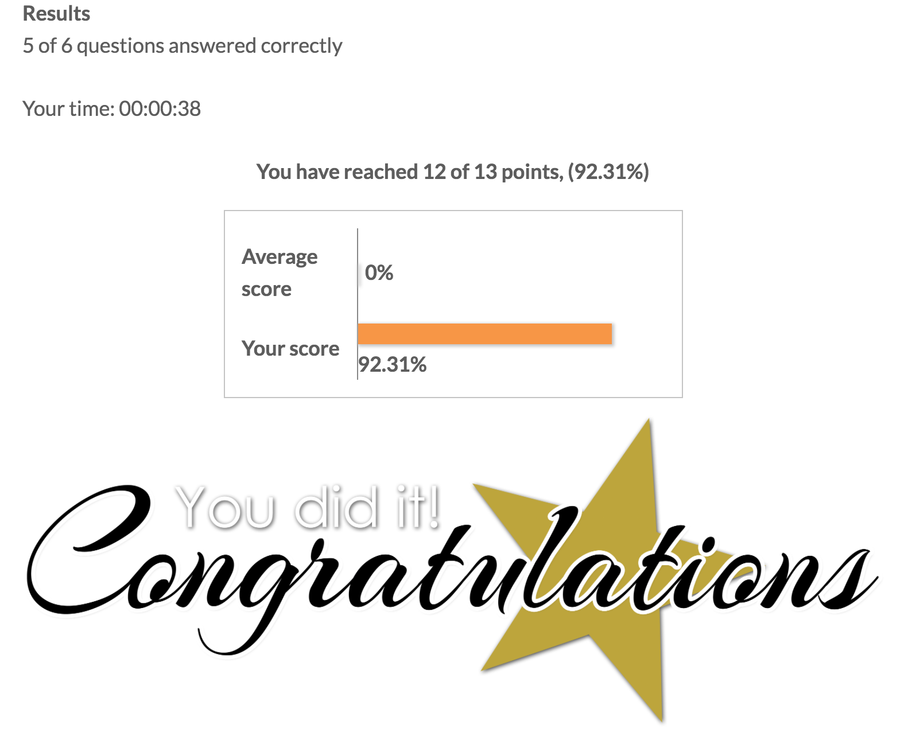

If your mark is below 60% for example, you will get something like the following screenshot:

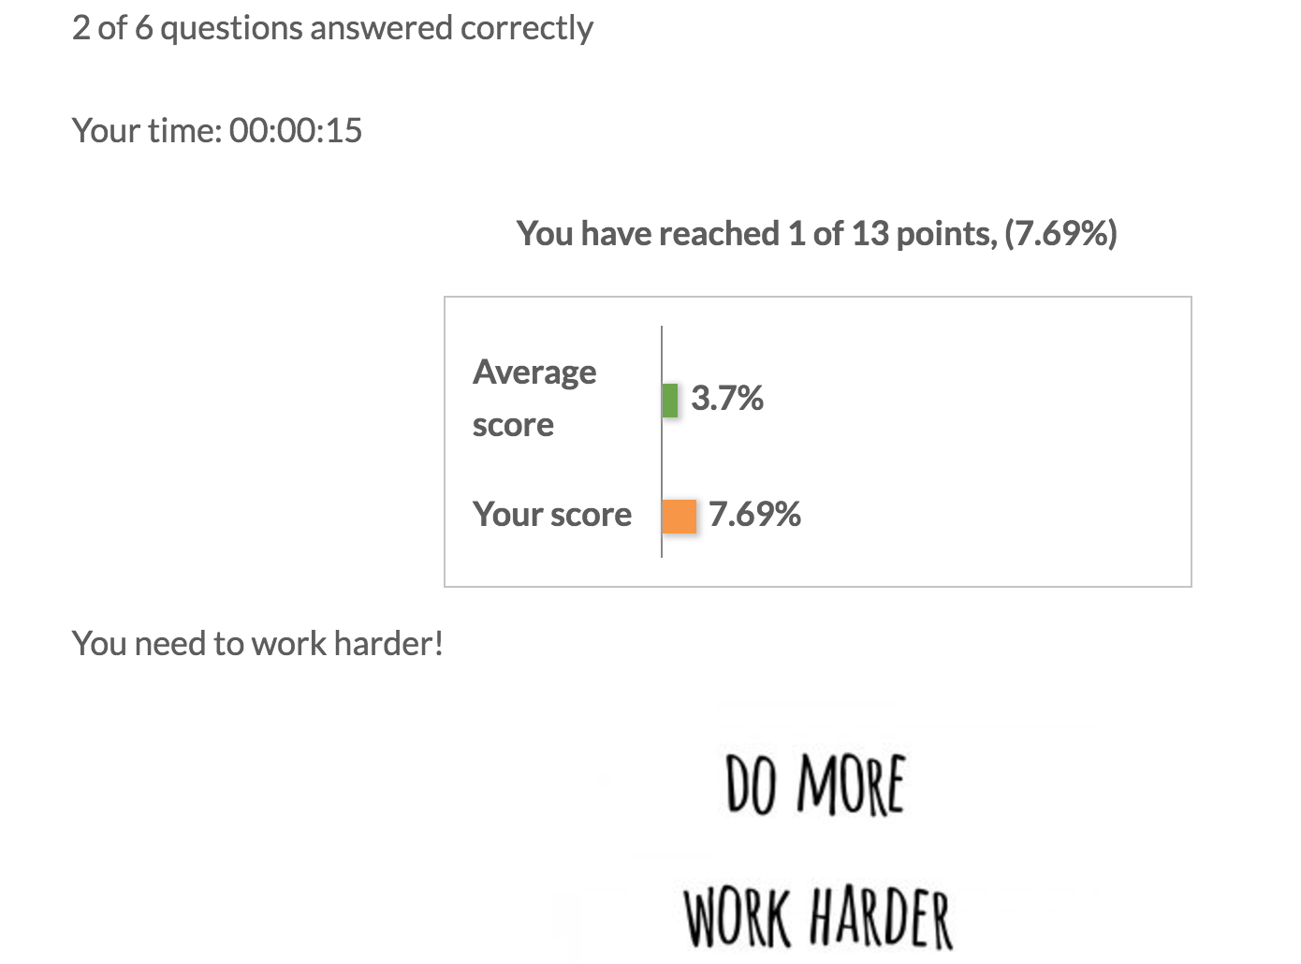

* 1. **Quiz And Survey Master (Recommended)**

It provides a free Add-ons names **certificates**, which can be used to offer a basic certificate for users who pass the quiz or test. With this add-on, the team can customize a title of the certificate, its message a background, and a logo. This add-on allows you to use a new variable %CERTIFICATE_LINK% to be used in your results pages and in your emails. You can apply some styling to the certificate’s message including underlines, bold, and italics.

../../../Desktop/27-15-02%253A07%253A26+PM+07%252F05%252F2017-0-100.

Also, it provides a link for students to download their certificates.

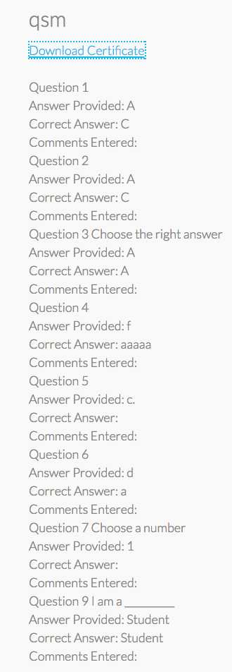

Top of Form

Bottom of Form

1. **Navigation & progress recording** 
   1. **LearnPress(Recommended)**

It provides the sections structure of each unit, so students can jump to any page within the unit randomly. Once you click the “complete” button, the current section will be marked as “completed”. In this way, it is quite easy and clear for students to recognize which sections of the unit have been studied already. And when you complete one section, at the left top, there also a progression bar presented to show you how far you are.

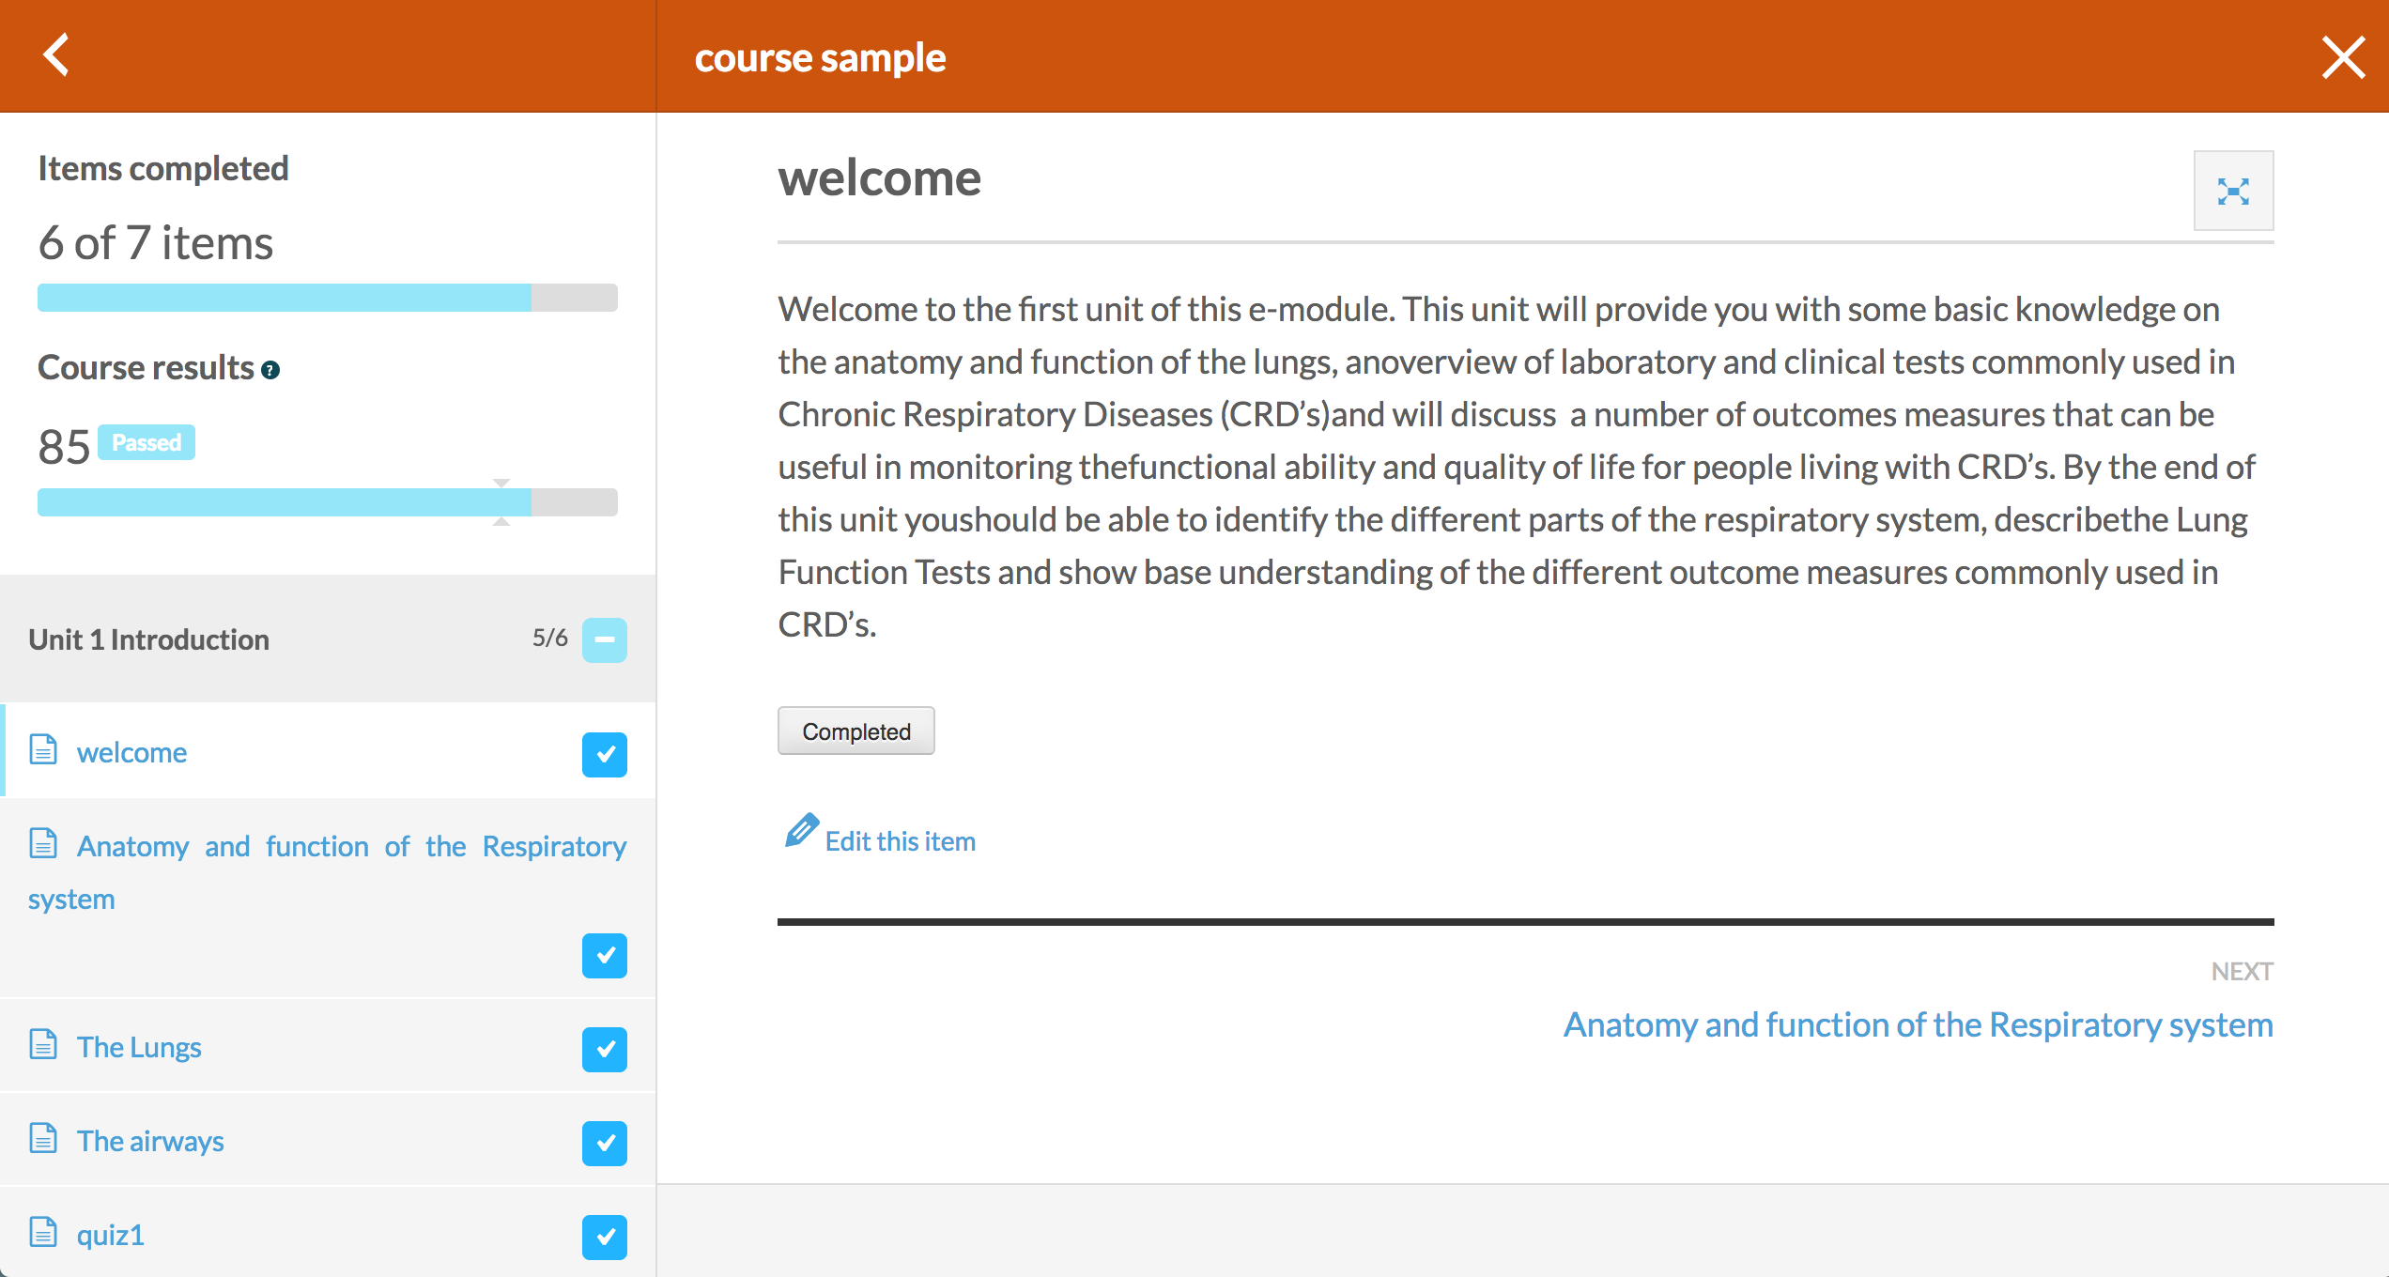

It also allows you to jump to other units randomly by clicking the “+” button of each unit, there will list the belonging sections under the unit. Therefore, in this way, students can jump to the sections in other units freely and easily. Similarly, only if you click the “complete” button, the current section will be recorded as “completed”.

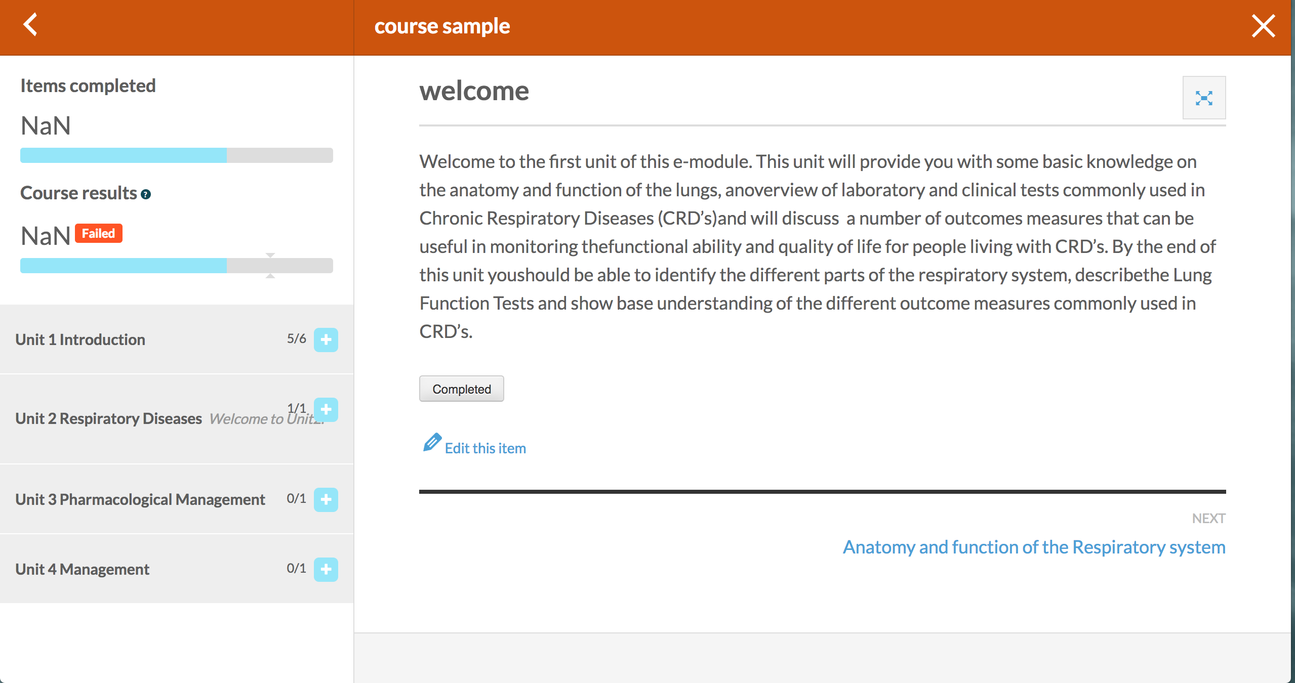

* 1. **CoursePress**

For the navigation within unit, it is easy for students jump to the next page and review the previous page by clicking the buttons “NEXT” and “PREVIOUS”. However, the **disadvantage** of CoursePress is that it does not give students a unit structure and section titles within the unit. Therefore, it is difficult for students to jump to the section they want to visit during their study. Students have to go back to the course overview page to jump to the sections they want according to the unit structure (providing section titles).

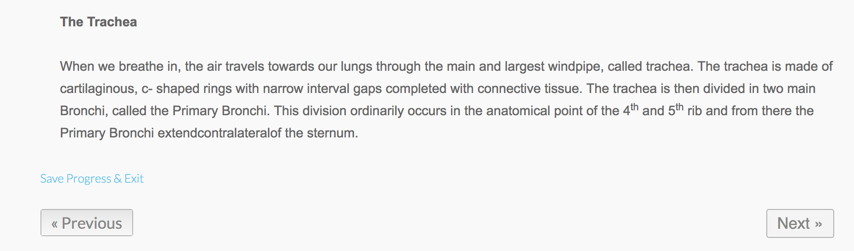

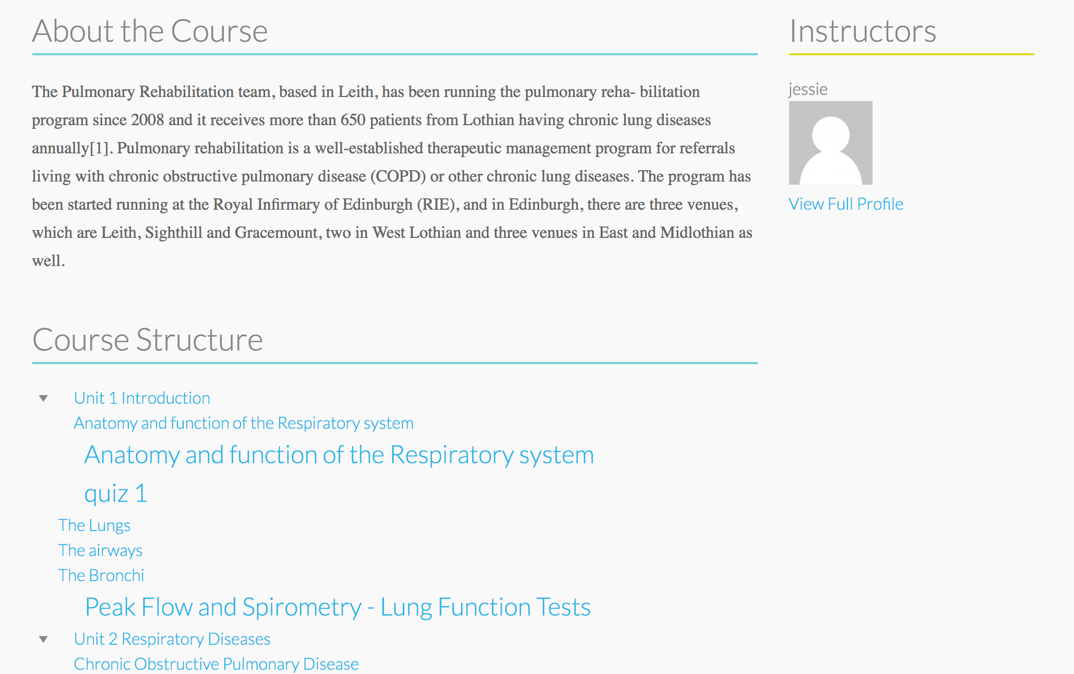

For recoding the study progress, students can click “Save Progress & Exit” to save their progression. And how much they have already studied in the **unit** level will be shown as a percentage on the course overview page. The **disadvantage** is that it cannot show students which pages they have already studied (in a section/page level), which means it can only tell you how much you have finished of that unit (in the unit level).

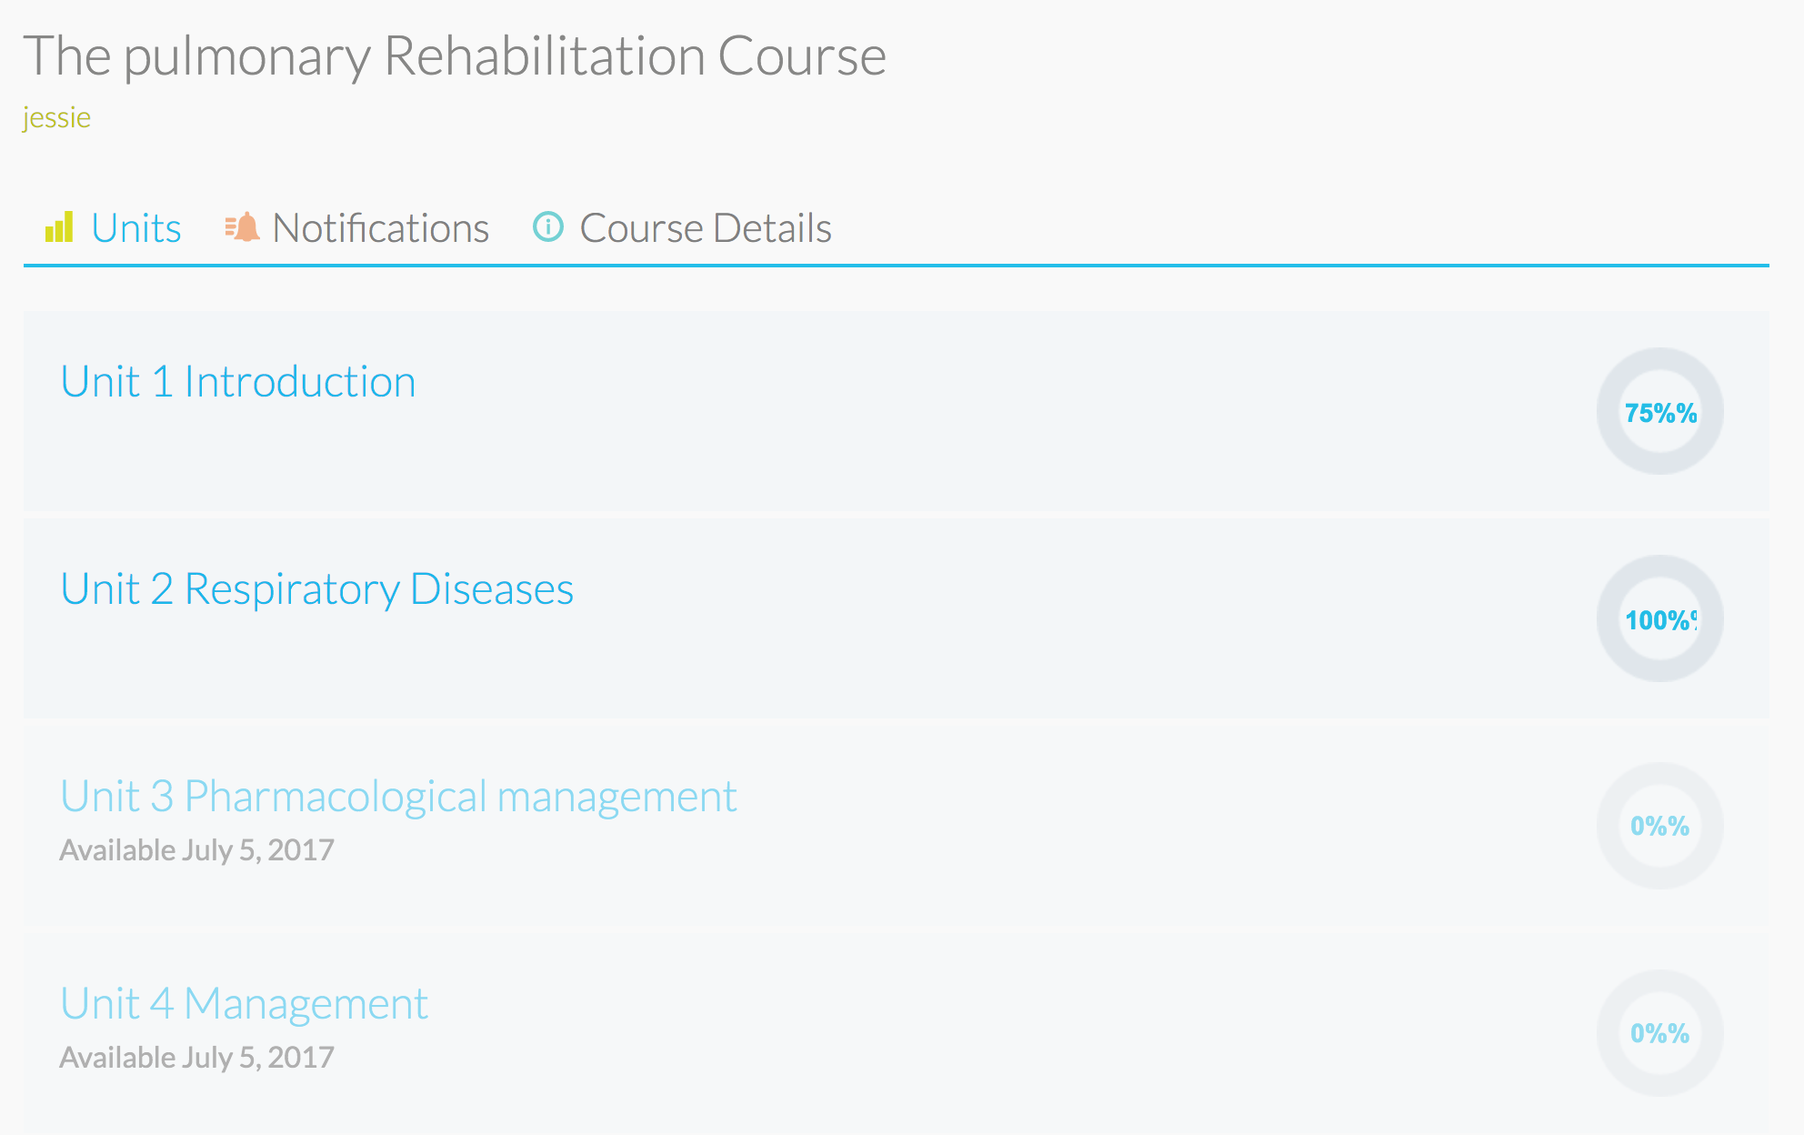

* 1. **Conclusion**

In my view, I recommend **LearnPress** than CoursePress. Because it can navigate students within a unit and between units with a clear sidebar providing the unit and section titles. It is much clearer and more convenient. And for the progress record, **LearnPress** also performs better but only on a unit level, but a section level. Therefore, students can have a clearer understanding about which section(page) they have finished. Additionally, when I implemented using CoursePress, I found there were some existing bugs, updating problems and the plugin did not work sometimes. According to the review of the plugin online, many people met this issue, so I think if we use it, we need to consider about the bugs and some update problems.

1. **Quizzes**
   1. **Single choice:**
      1. **WP Quiz**

It provides an interesting quiz type named “Trivia”. It can create single choice questions quickly and easily. When people give their answers, the platform will give the correct or incorrect information. It supports image/video media for the questions and image for the answers. The interface looks like:

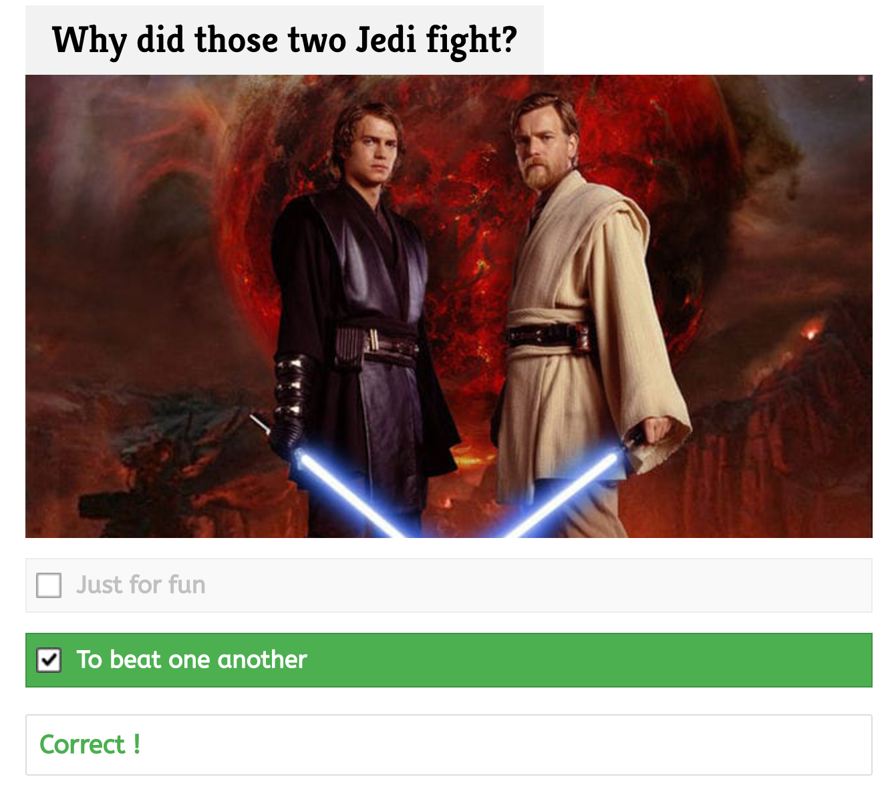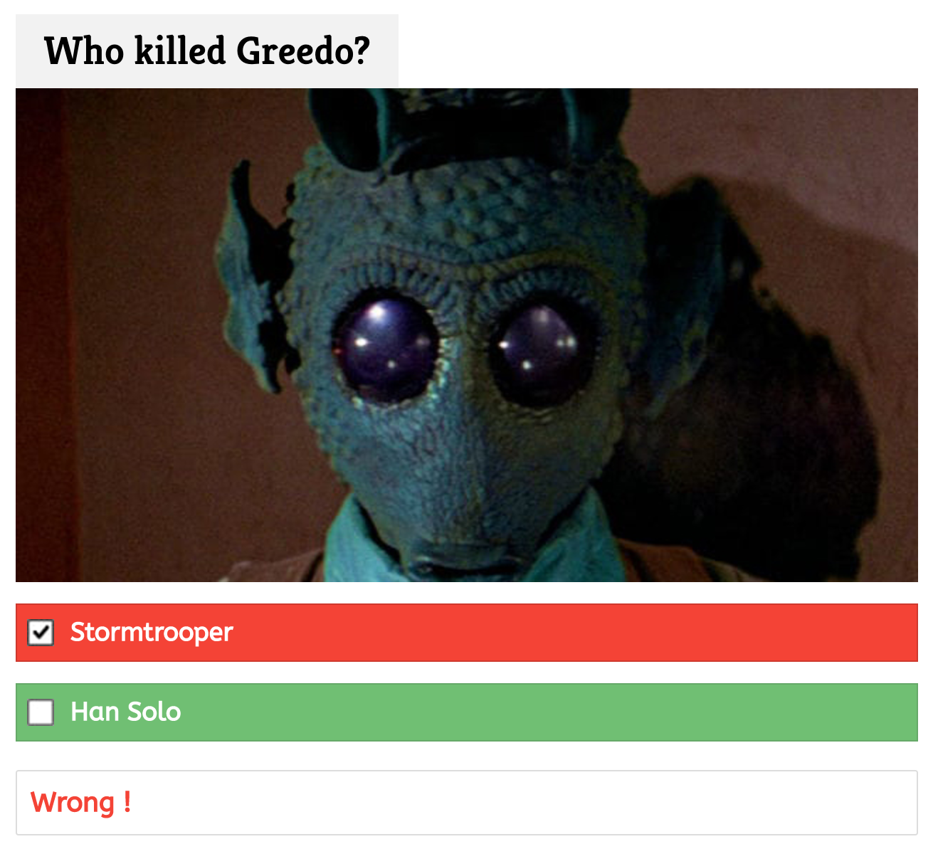

I advise that this plug-in can be used as a quick test during the study, so students can check how they understand the knowledge. But the **disadvantage** is that it cannot give an explanation for the correct/incorrect questions.

* + 1. **WP-Pro-Quiz**

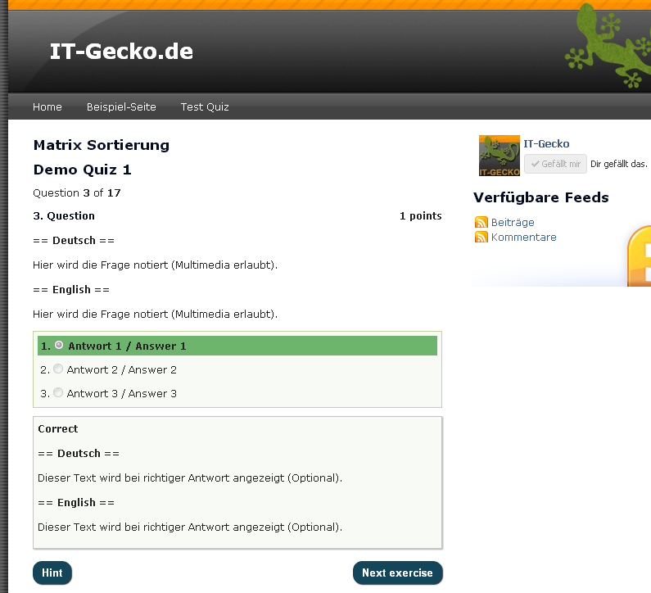

* 1. **Multiple choice**
     1. **WP-Pro-Quiz(Recommended)**

WP-Pro-Quiz is a powerful and beautiful quiz related plugin for WordPress. It supports not only multiple choice, but other types of quiz including single choice, “Free” choice (long/short answer), “Sorting” choice (drag the option to make it in the correct order), “Matrix Sorting” choice, gap filling, and assessment (for example, choose from 1 (less true) to 5(more true)). There are a lot of **advantages** of this plug-in. It supports **Random questions and answers**, **time limit, multimedia in questions, back-button, correct/incorrect response message for all questions, different points for each question and answer, result text with graduation** (mentioned above in certificate & rewards chapter), **statistics analysis, leaderboard, hint, category support, E-mail notification, import/export function, and custom fields.** Also you can choose when to check the answer (immediately/at the end).

The following screenshot shows what the multiple choice looks like. Its **disadvantage** is that it does not provide many stylings.

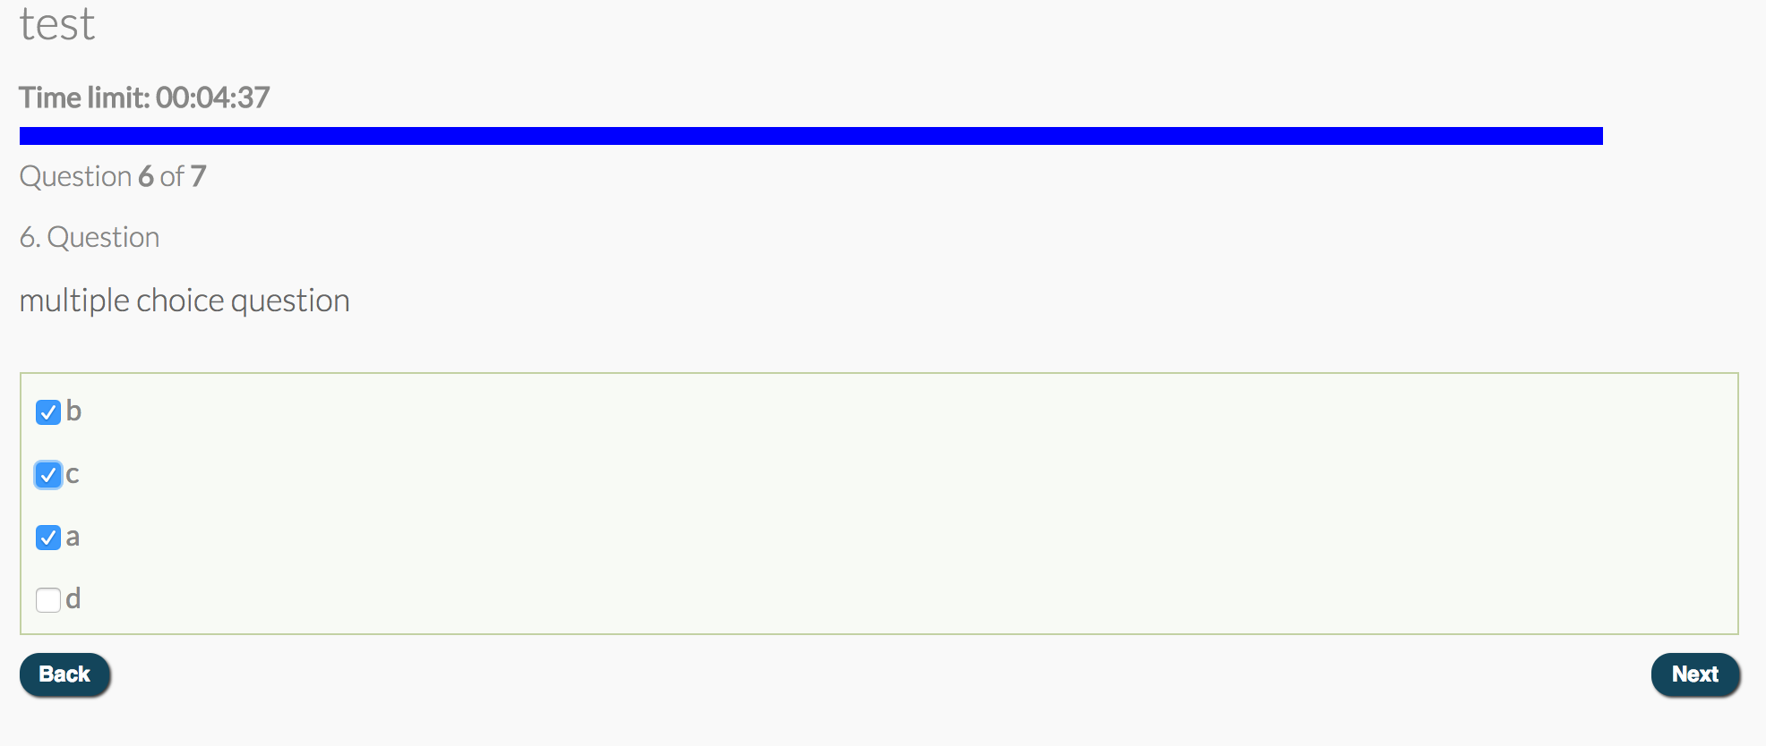

As what mentioned above, it is available to insert different media in the question and answer, the following example shows how to use a video as a material to ask questions.

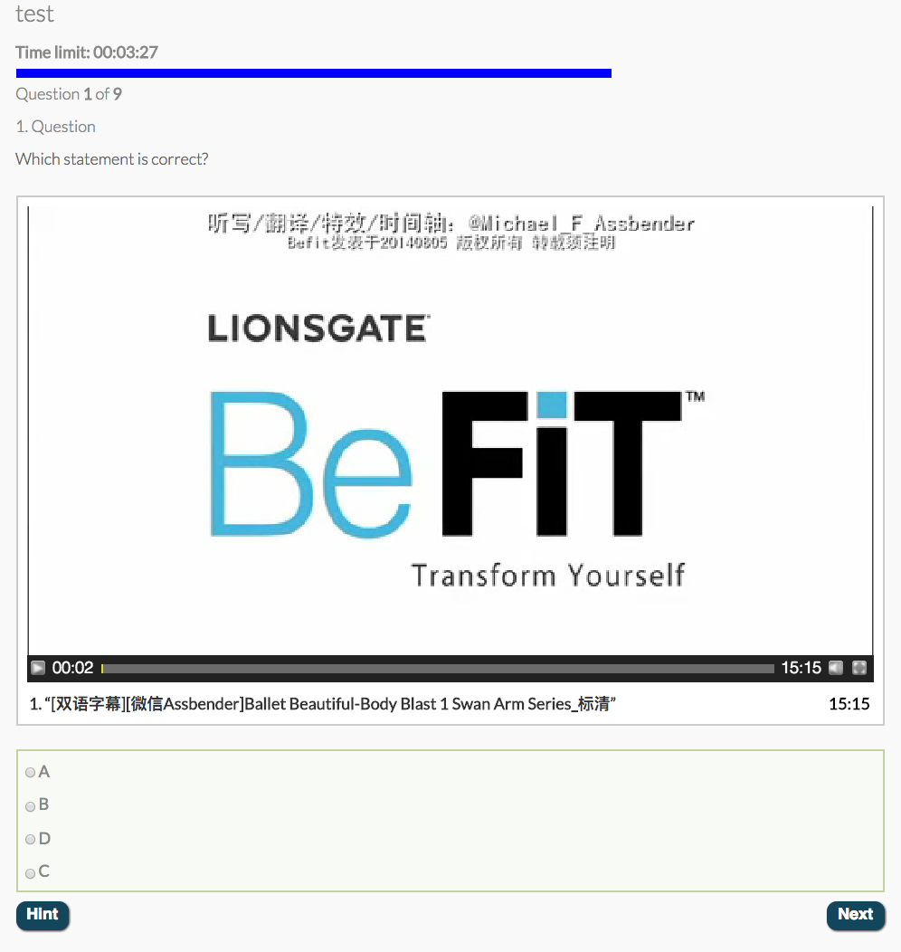

* + 1. **Quiz And Survey Master**

It is quite similar.

* + 1. **Conclusion**

Multiple choice and single choice, as the most basic question types, different plug-ins do not reflect too many special differences. The two main differences may be the styling or the answer direction (horizontal or vertical) and some quiz setting like time limit, hints, explanation and so on.

* 1. **Myth or Fact (True or False)**

This type of questions can use same plug-in as single choice discussed above, because True or False is also a kind of single choice. I **recommend** to use WP-Quiz to create the quick test during the study, and use WP-Pro-Quiz to build the quiz at the end of each quiz.

* 1. **Drag and drop (Incomplete stories)**
     1. **WP-Pro-Quiz**

It can create the following “drag and match” by using the “Matrix sorting choice”. It supports to insert image and allow html in both questions and answers. (Although I met problems when I tried to insert image to the question, I guess this problem can be solved). Therefore, for the questions of incomplete stories like the following example (from unit 1):

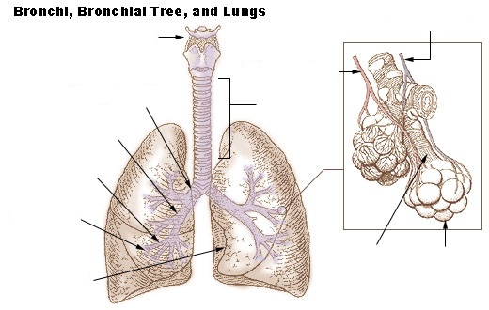

I think we can number the different parts of the lung, and ask students to match the correct responding name of them by dragging the choices to the correct number.

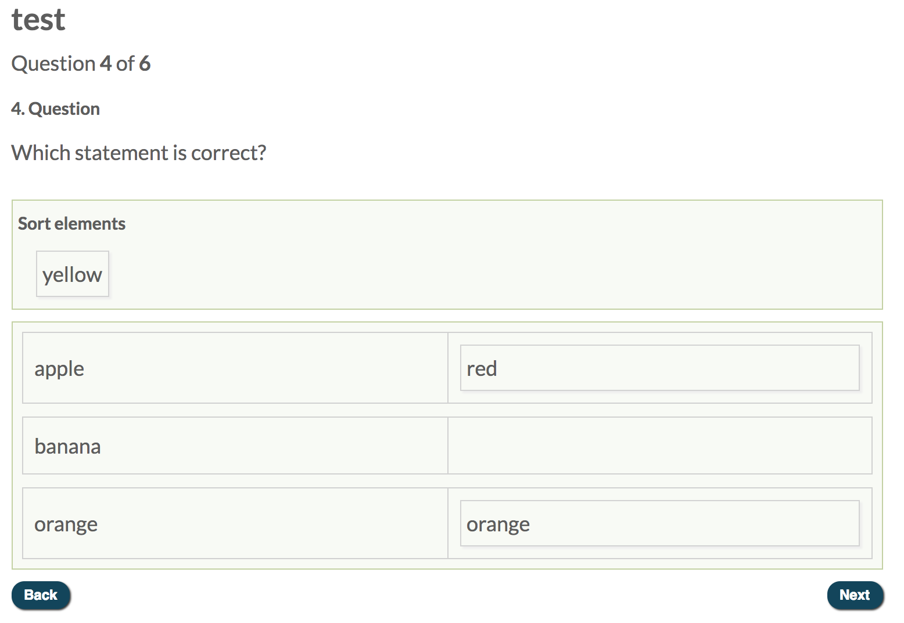

**5.4.2** more here…

* 1. **Case study**
     1. **WP-Pro-Quiz**

For **Story-based** and **Read/Watch and Reflect** questions, I found that WP-Pro-Quiz can only provide a small answer box for the scenario, which is one of the most **disadvantages** of the plug-in.

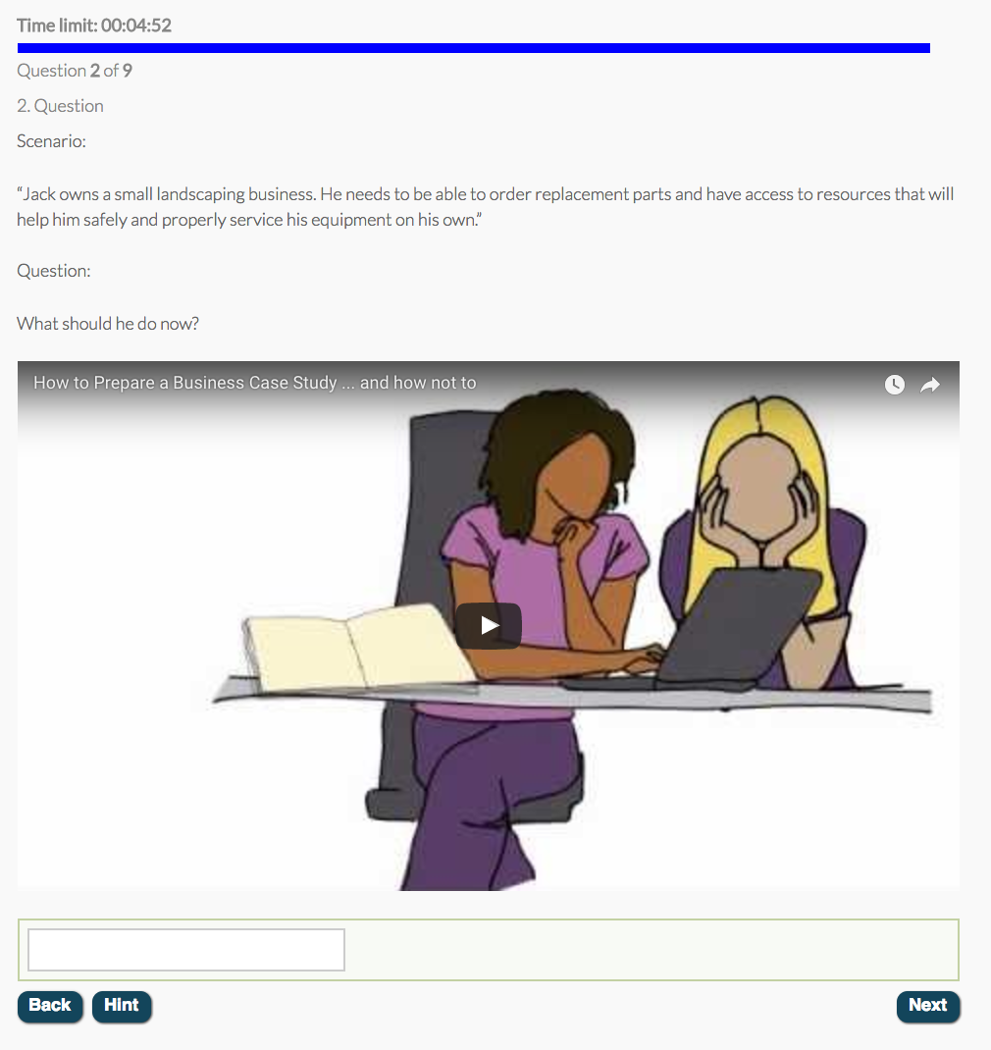

* + 1. **Watu Quizzes:**

Watu Quizzes (free version) can only provide three types of questions: single choice, multiple choice, and open end(essay), which can be used in case study.

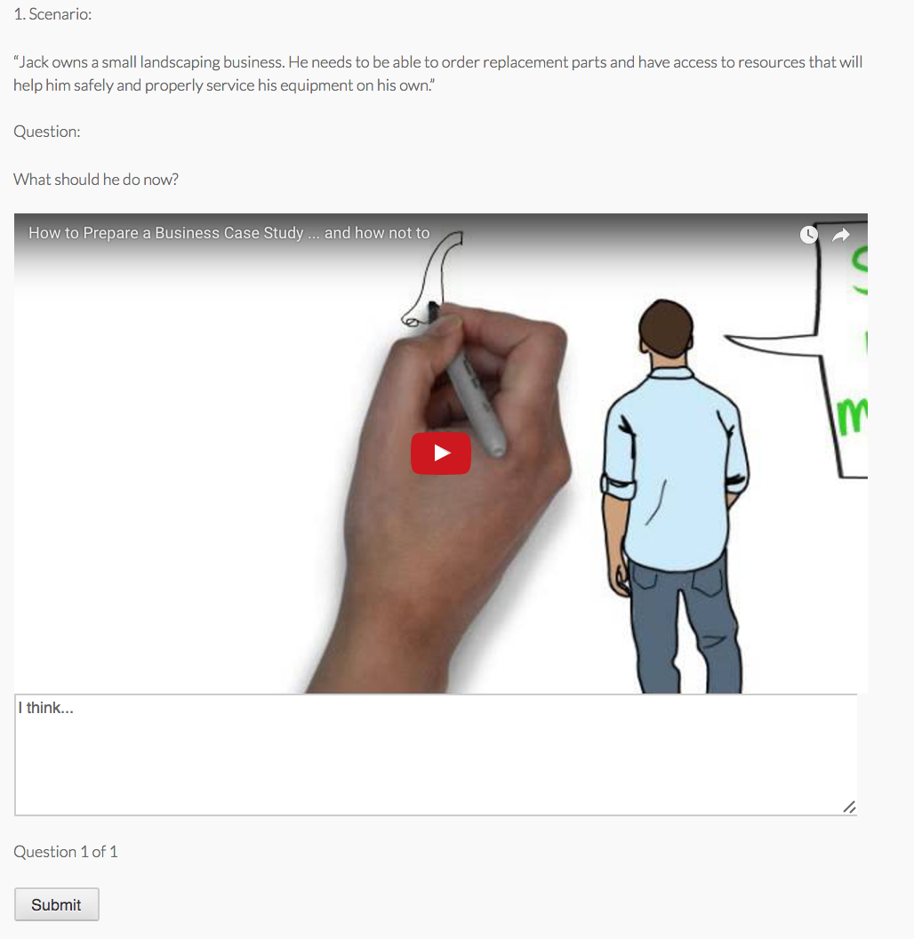

Once students click the “Submit” button, the answers will be shown in the screen with your grade. The grade interface can also be custom according to different grades. The main **disadvantage** of Watu Quizzes is the limited question type. If you want to create more types of questions, you have to buy the Pro version. But the WP-Pro-Quiz and Master

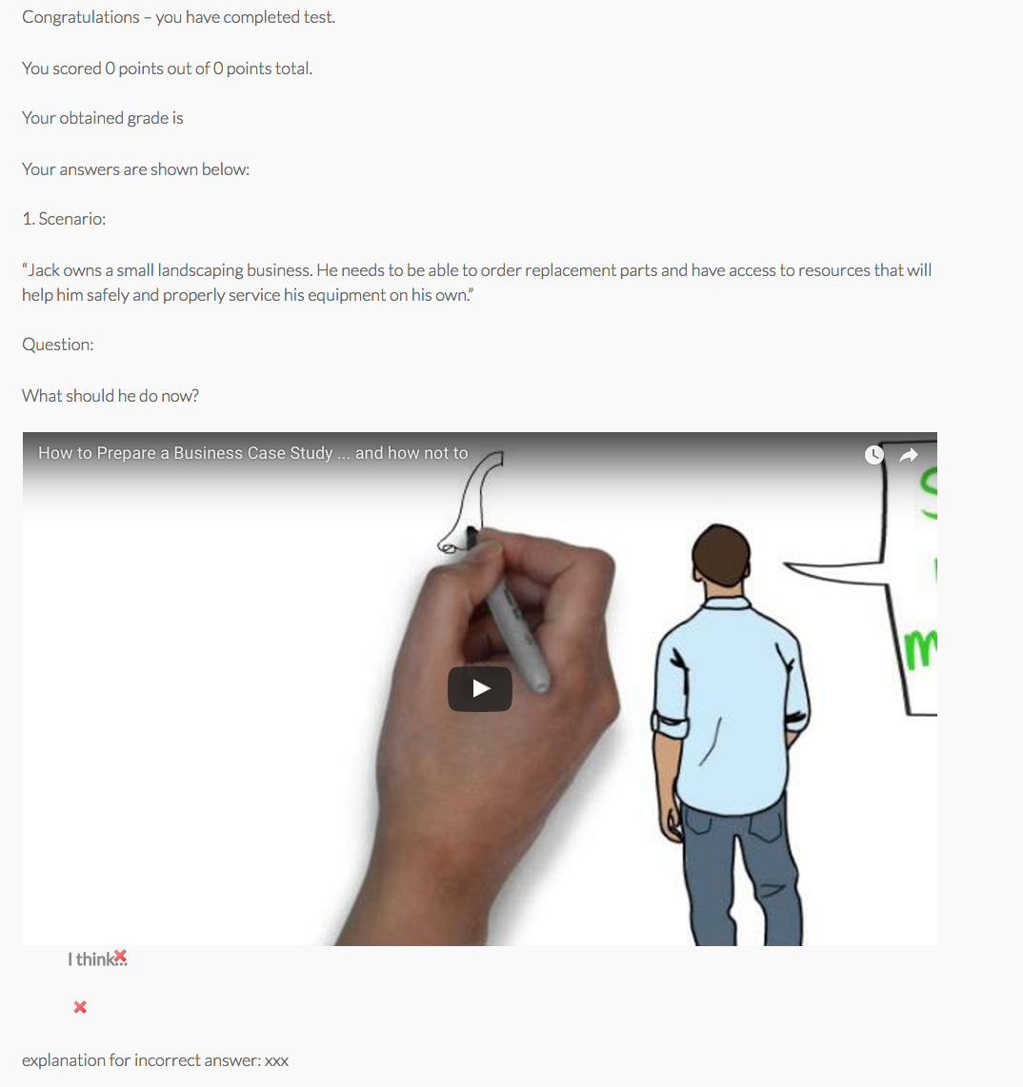

* + 1. **Quiz And Survey Master (Recommened)**

It provides **Large/small open Answer** for case study questions. According to Marnos said in the last meeting, we do not need short answer, so I only give a long answer example as follows. It only support insert media in the questions, not for answers.

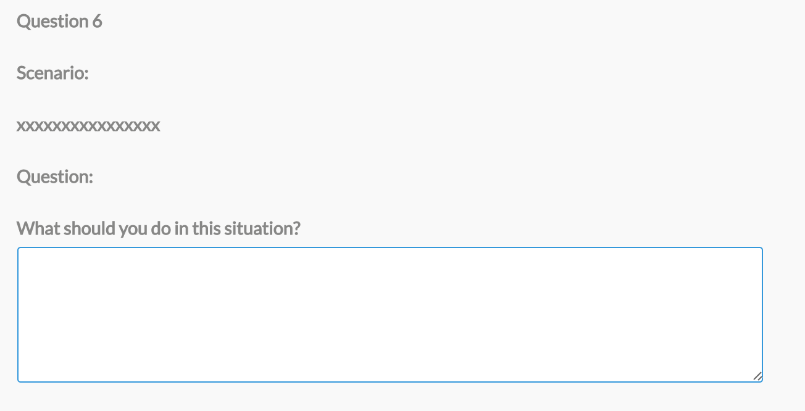

* 1. **Gap filling (Incomplete stories)**
     1. **WP-Pro-Quiz**

For the “incomplete stories” questions, the learners are asked to fill in appropriate words or drag in images to complete a story that has several pieces missing. Therefore, for this type of interaction, we can use the functionalities of **Matrix sorting choice** and **Cloze**

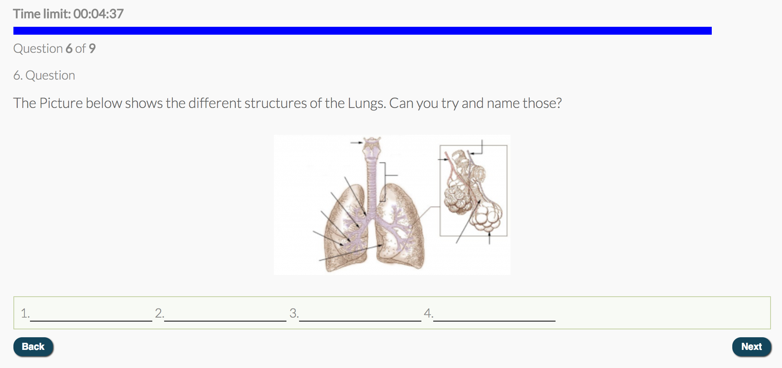

* 1. **Quiz And Survey Master**

It is similar to the previous one.

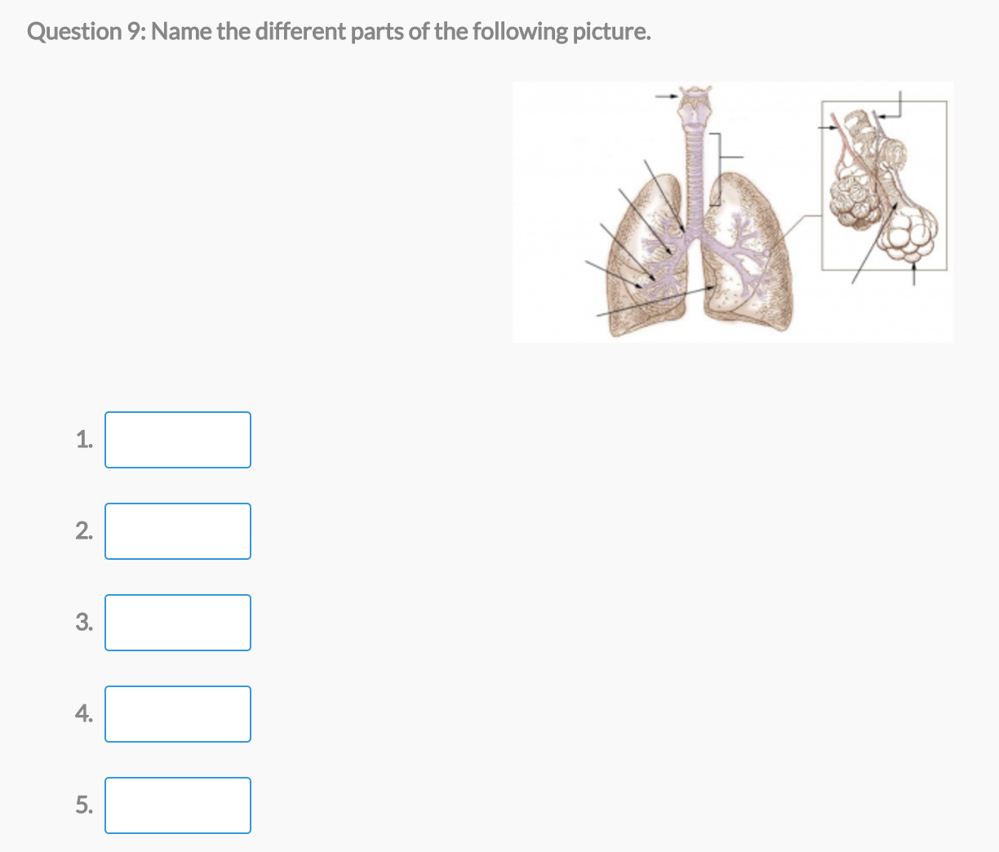

* 1. **“What is wrong with this picture (12)”**
     1. **WP Quiz**

WP Quiz provides an interesting feature named flip cards, which can be used for enhancing the study experience. It supports the front and back images. It can be used in enhancing memory of knowledge and figuring out what the mistakes in the picture.

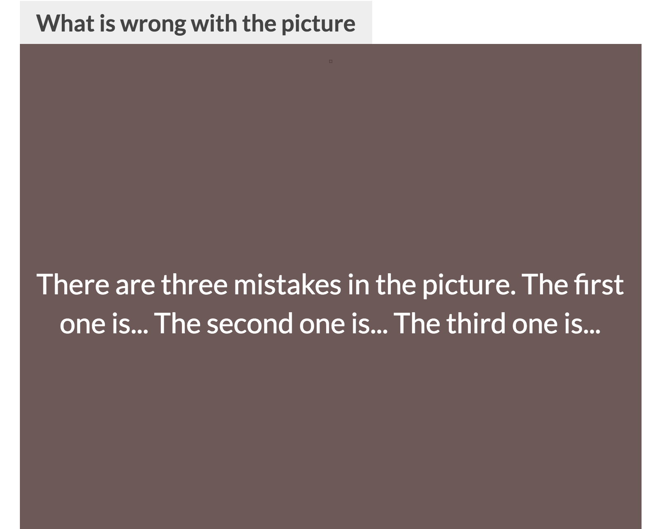

* 1. **Sorting (order of importance/scattered steps)**
     1. **WP-Pro-Quiz**

It provides a **Sorting choice** question type, which can be used into the interaction of **order of importance** and **scattered steps.** The choice can be dragged and moved to make the sequence correct.

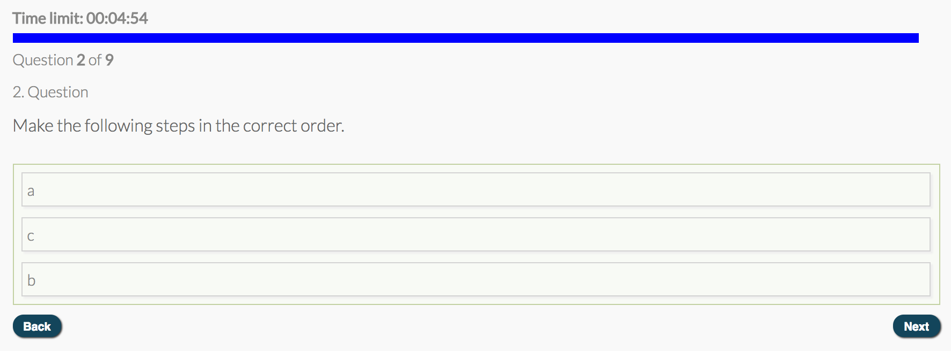

**Back-end plug-ins:**

1. **Editing quizzes**
   1. **WP-Pro-Quiz**

The quiz overview interface looks clear and it is easy to manage all quizzes you created. You can import and export data. For apply the quizzes you created, you only need to use their responding shortcodes in your lesson page and that’s it. Additionally, quizzes can be organized by catefories.

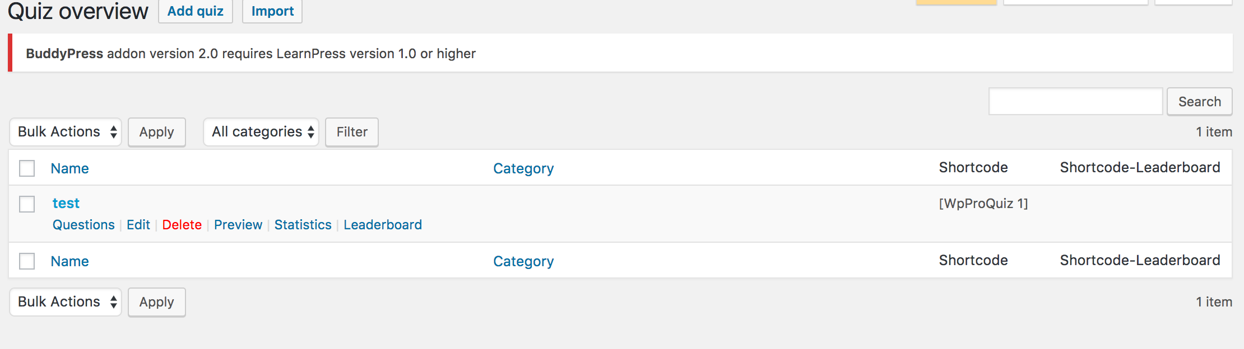

When you click the “**Edit**” button, you can edit the basic setting of your current quiz. The following screenshot is not completed. I just want to use it to show you how the **Edit quiz** interface will look like. It is easy to use and manage, even though the team staff are not professional IT people.

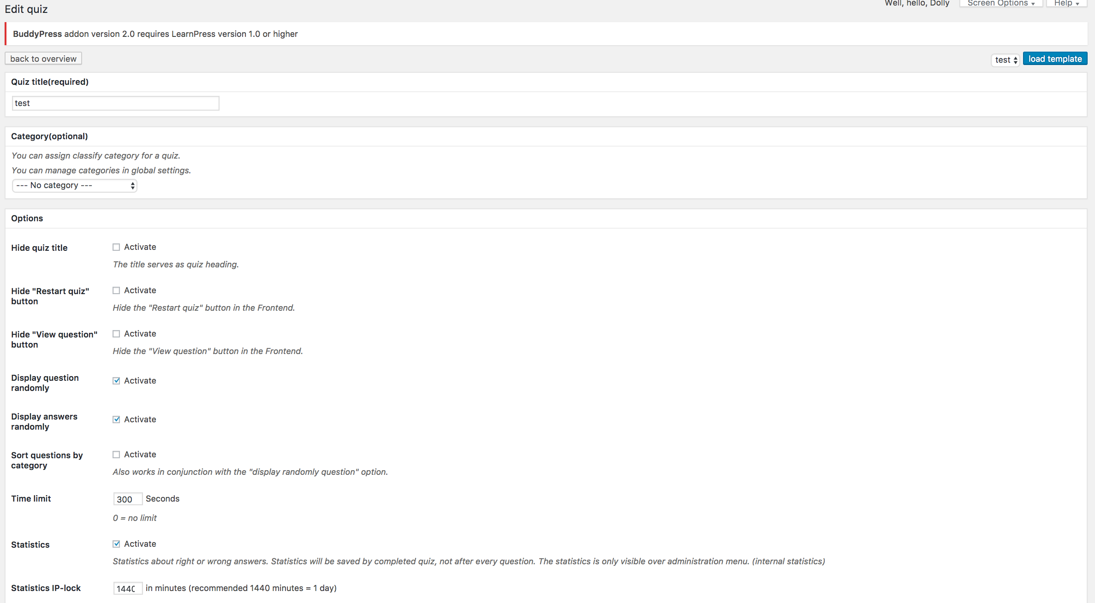

* 1. **Quiz And Survey Master**

The quiz overview interface of Quiz and Survey Master is similar to WP-Pro-Quiz, the only difference is that it can show you how many times people view the quiz and how many times the quiz has been taken.

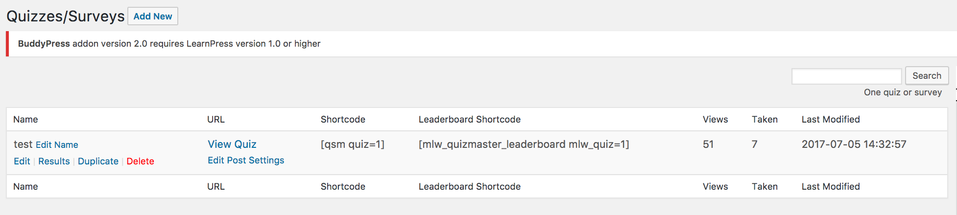

Once you click “**Edit**” button, you will go to the quiz setting page, the **advantage** of this plugin is you can clearly see what the question contents are types are. And another **advantage** is that you can reorder the questions directly. Additionally, the most **convenient** thing is that you can change the setting of the quiz and questions both on the top bar of the following page by switching the tabs.

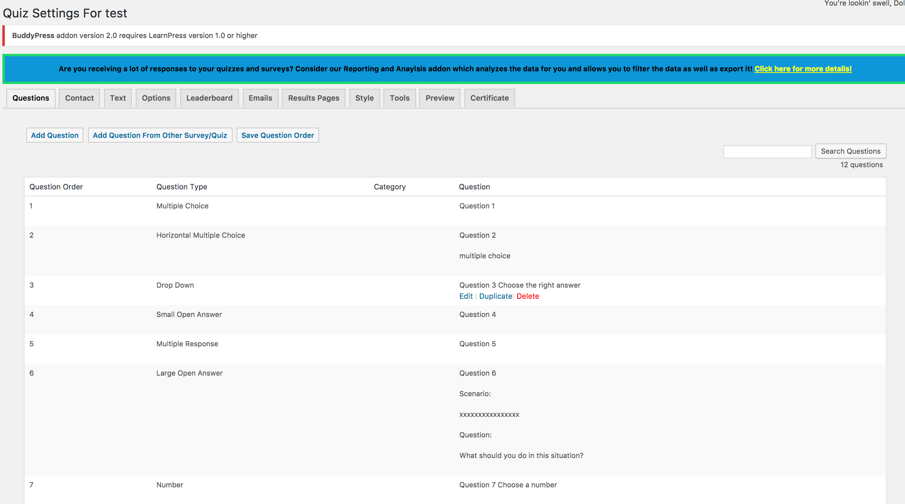

**2. Editing questions**

**2.1 WP-Pro-Quiz**

**2.1.1** The following screenshot is for the question editor. You can sort the order of the questions by click “**Sort questions**” and other features are similar to the previous one actually.

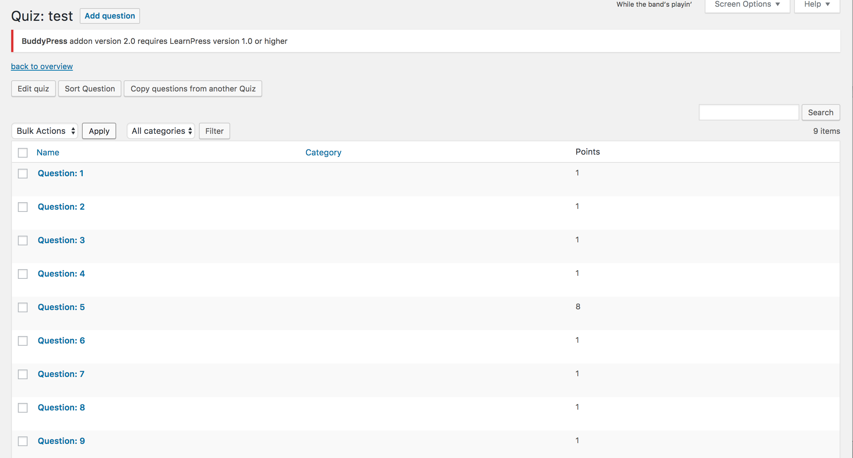

If you want to remove any question, just click the check box of that question and choose **Delete.**

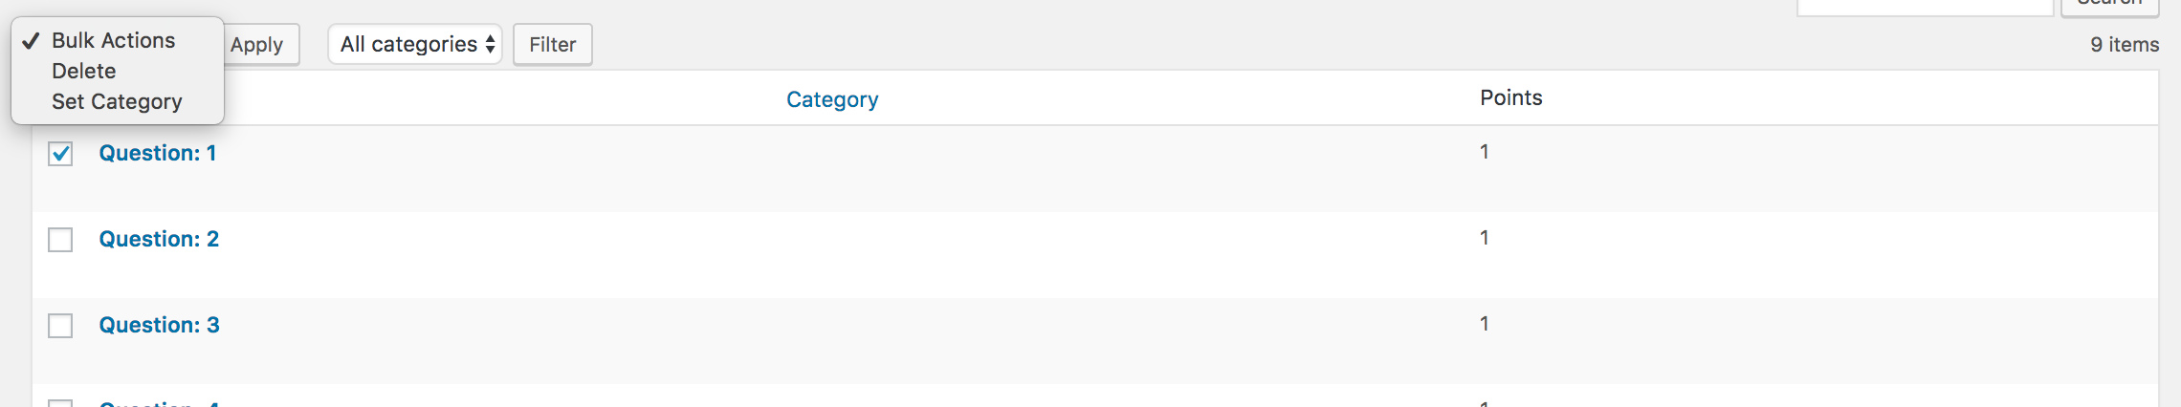

**2.1.2 Editing particular question**

You can edit the title, explanations, hints, points, categories, answers and question types easily.

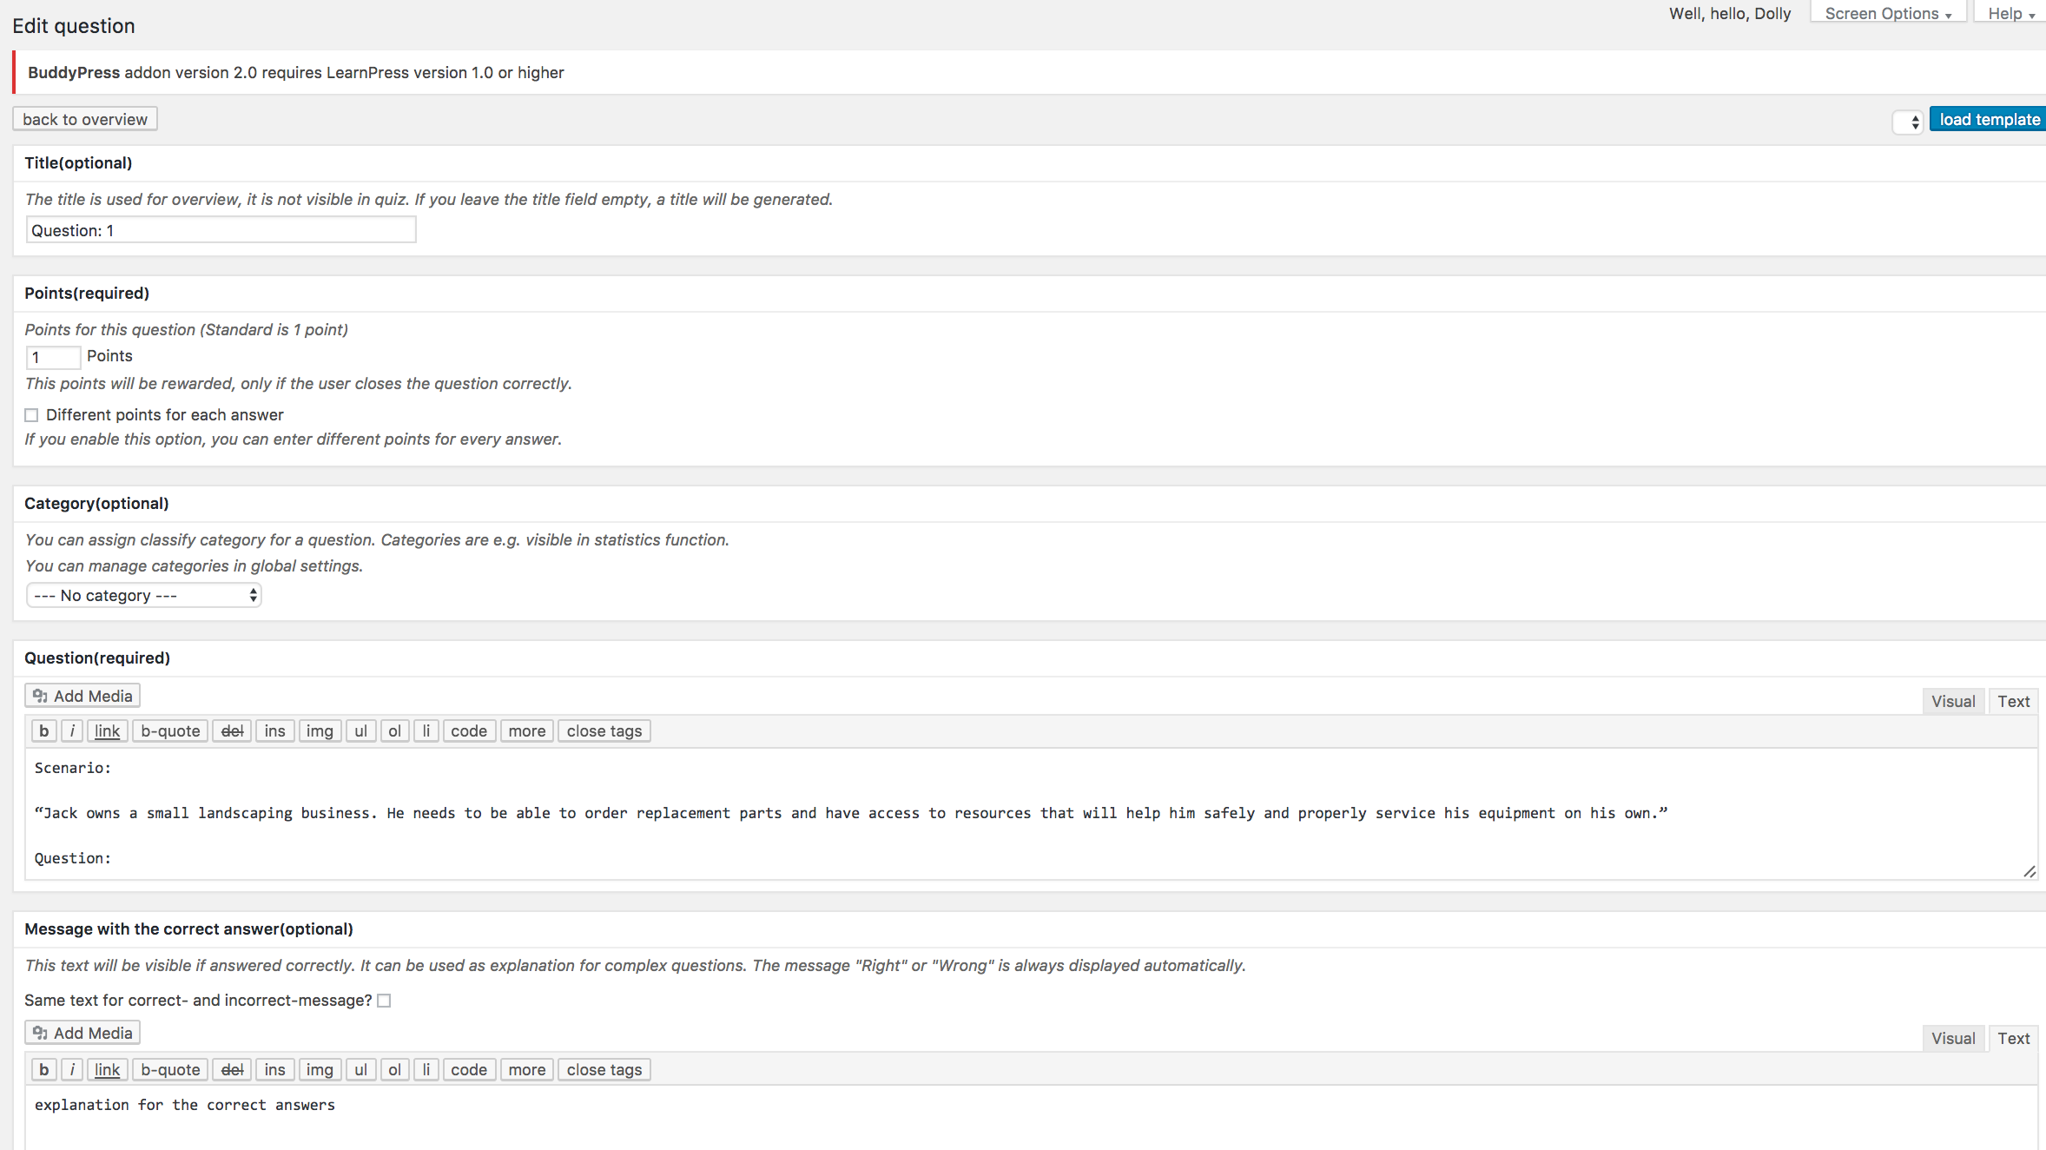

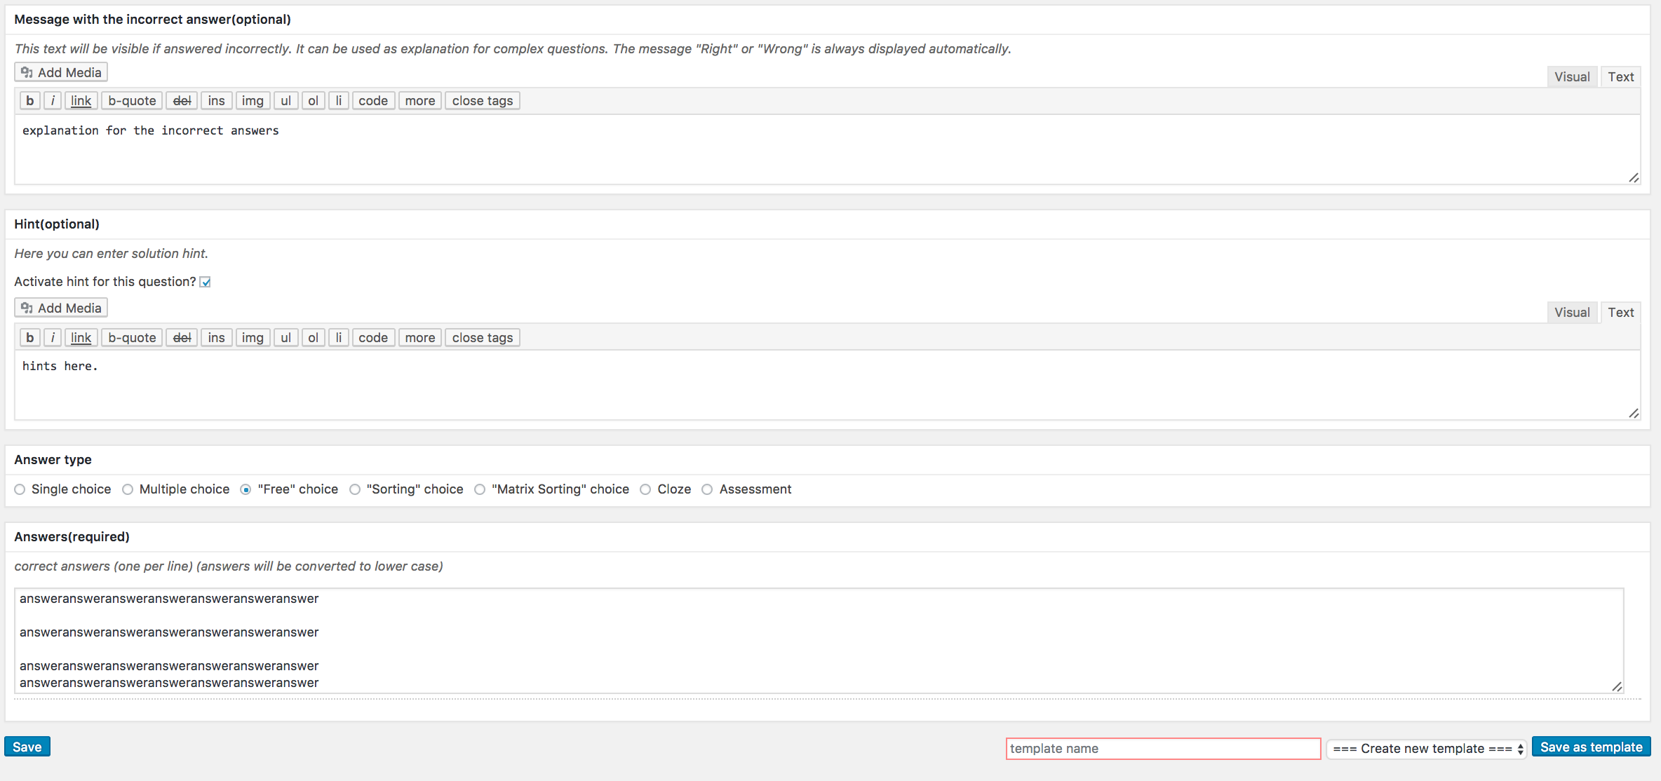

**2.2 Quiz And Survey Master**

**2.2.1** Except what have mentioned in 1.2, under the existing questions list, there is a quick question editor. It is quite convenient to add a new question directly by scrolling down to the end of the questions overview interface, instead of opening a new page by click “**Add question**”. Quiz And Survey Master provides two ways for adding questions.

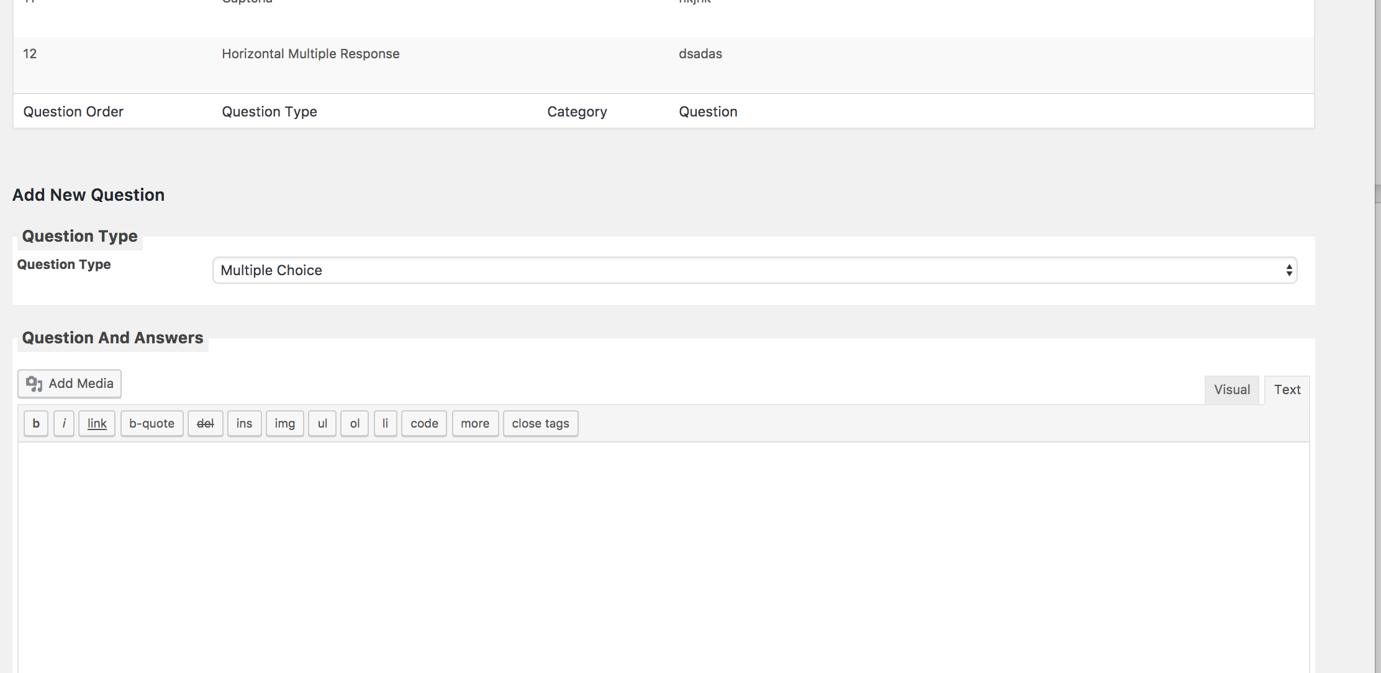

**2.2.2 Editing particular question**

By clicking **Edit** for the particular question, you will be navigated to the end of the editing question then you can edit your questions.

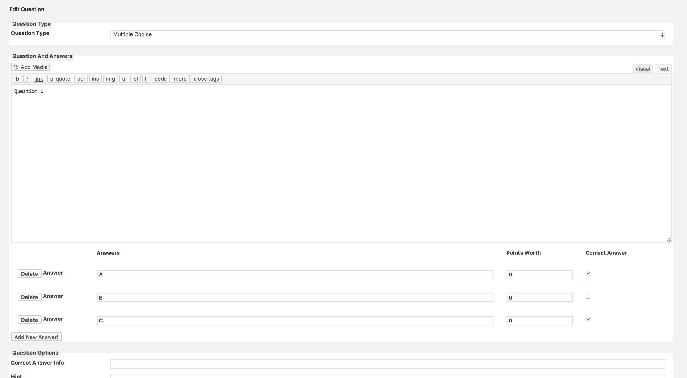

1. **Theme changing**

Some plug-ins mentioned above have their themes in the paid version. I can’t try them unless I paid for it. But for the free themes, if you want change the theme, you can go to the **Appearance** tab on the dashboard and then choose **theme**. Then you will be available to change the theme.

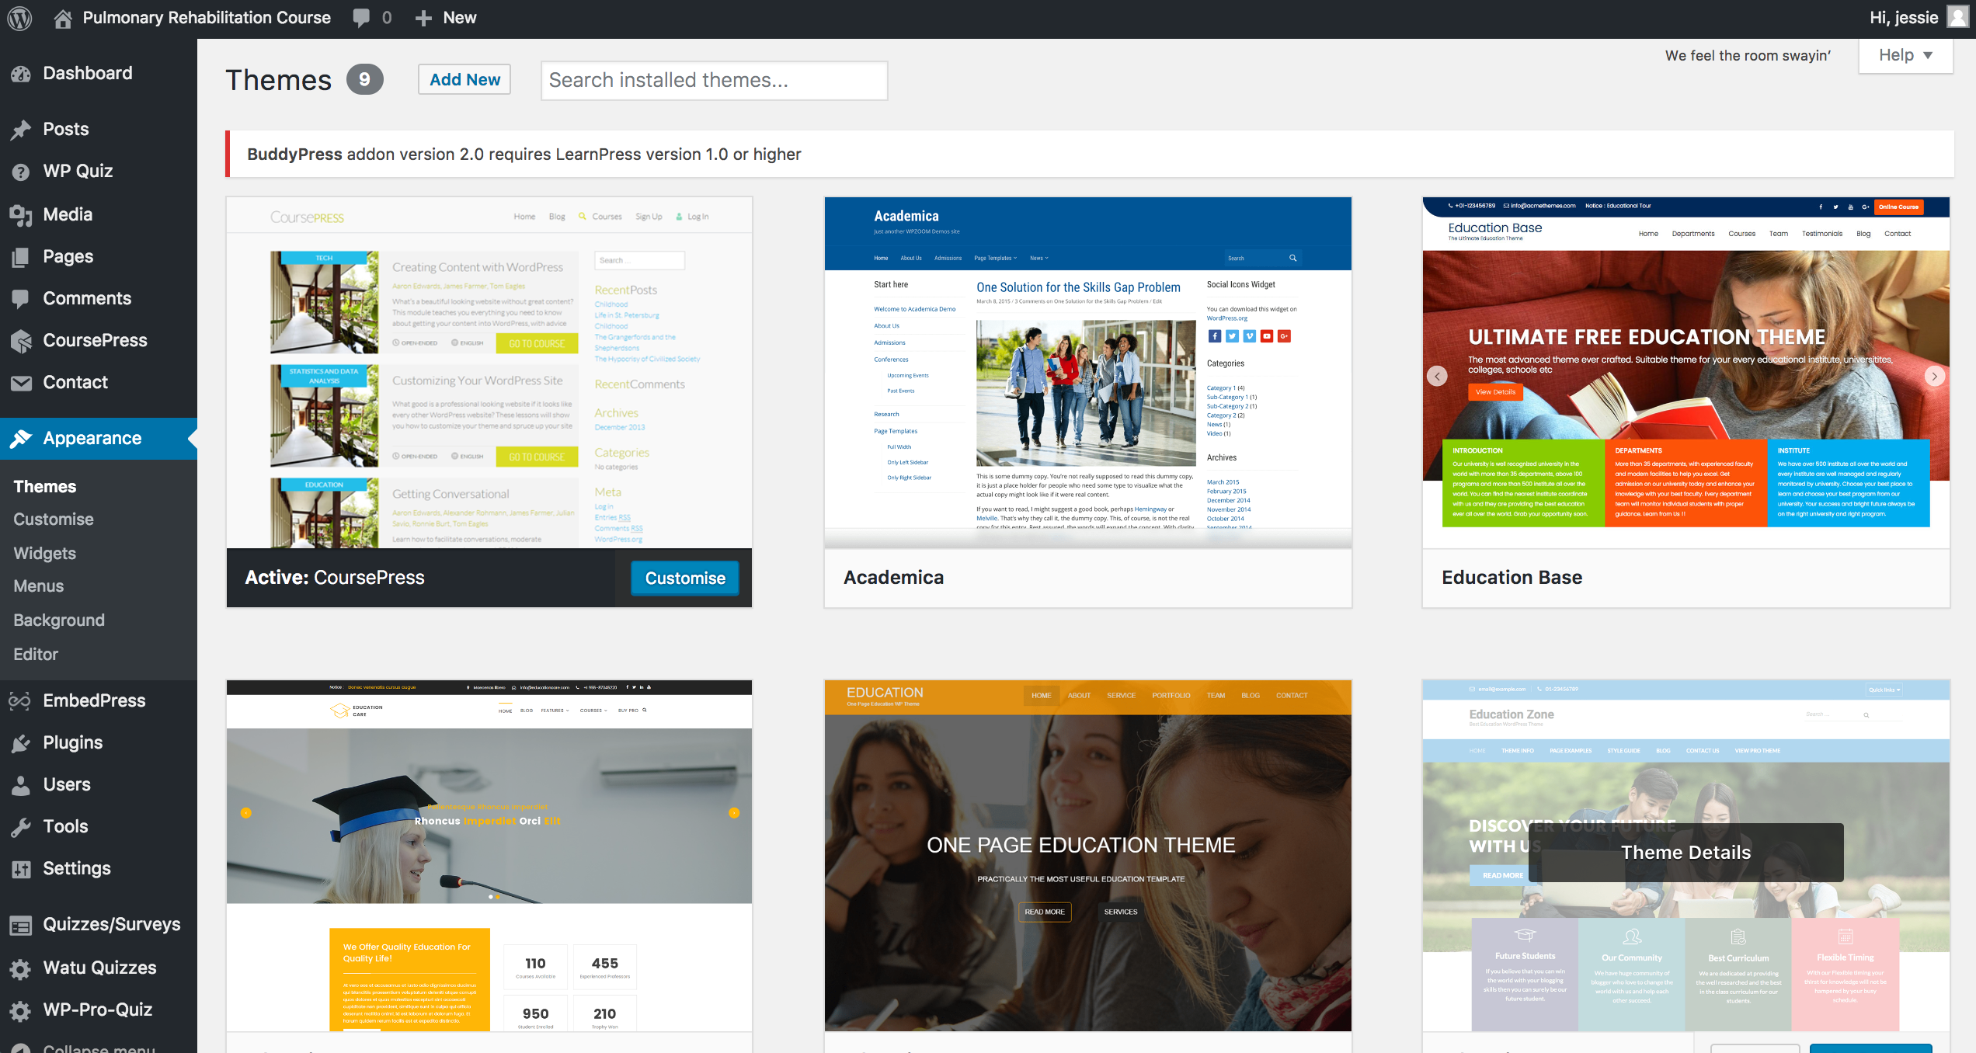

And you can customize them too.

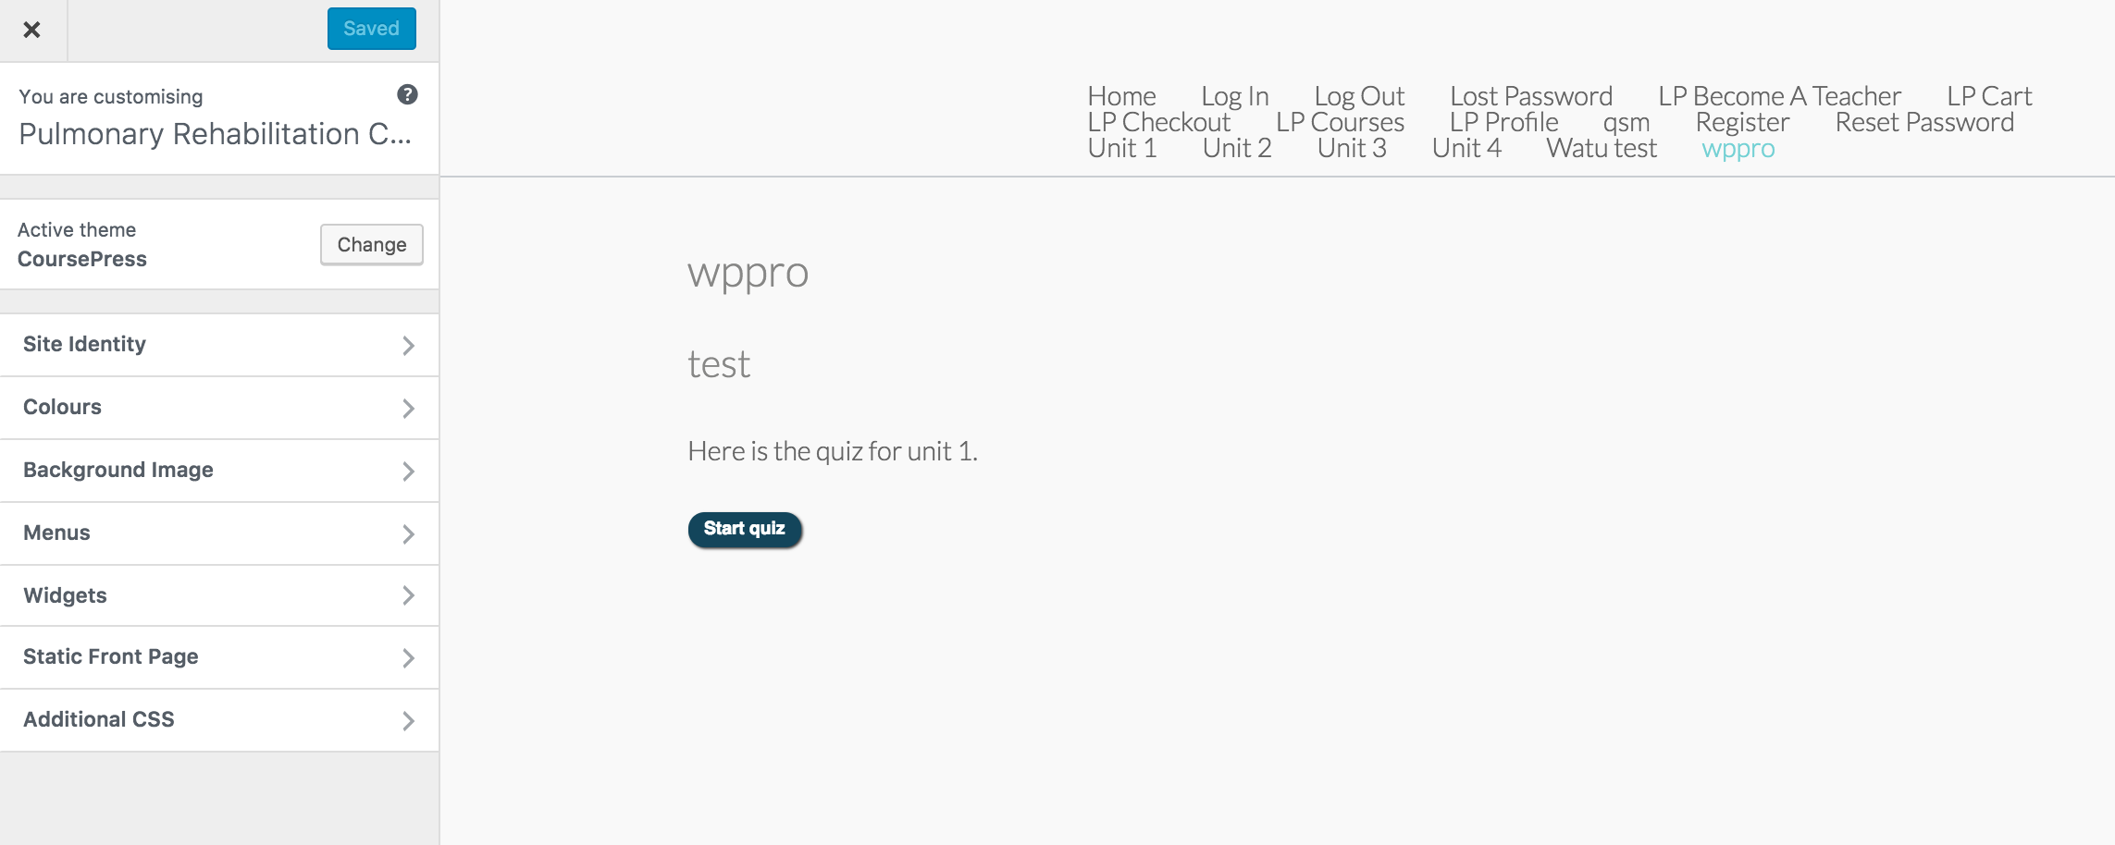

1. **Back-end updating**

Plugins may have regular updates. If there are any plug in needs to be updated, you can just go to **Plugins** to make the one-click update quickly.

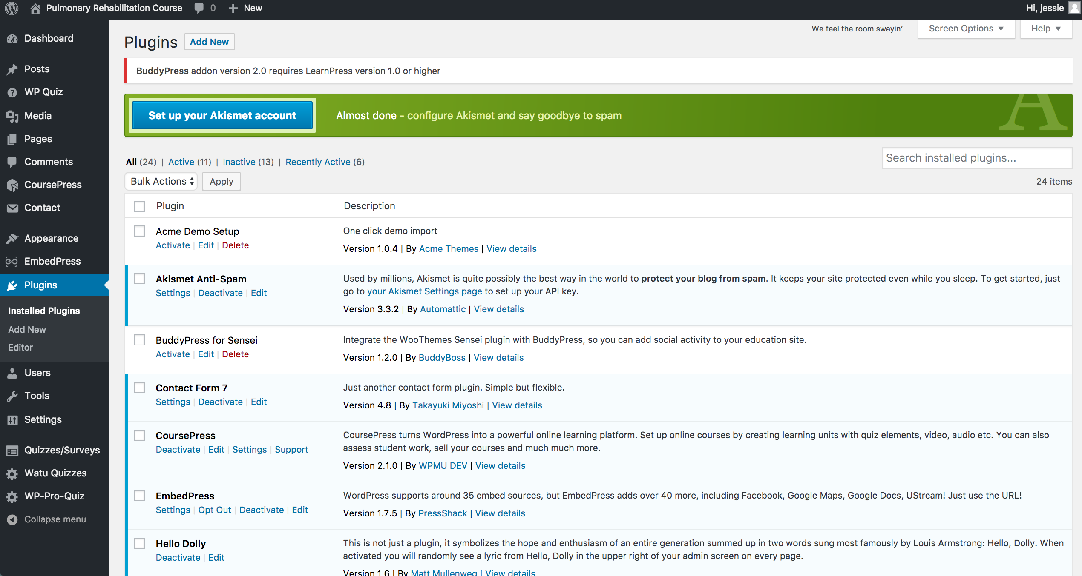

**4. Data and statistics**

**4.1 WP-Pro-Quiz**

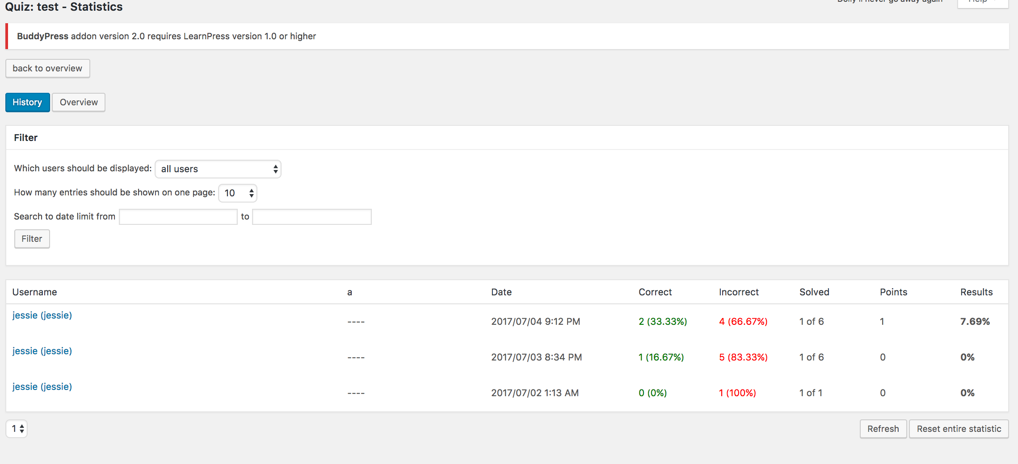

**Overview** feature can provide you the overview performance of each student.

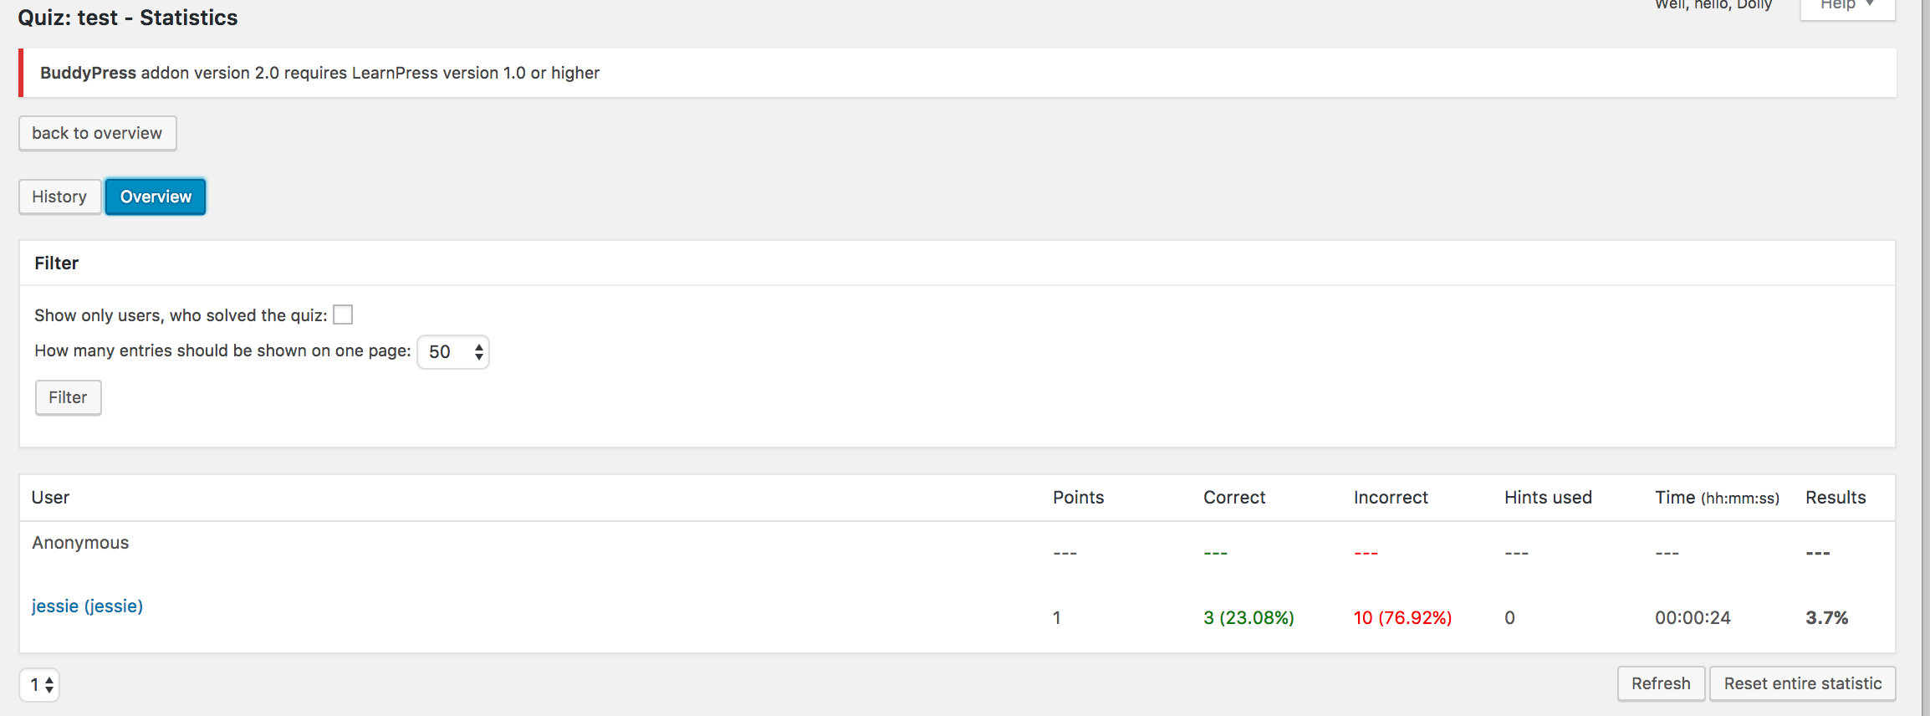

**4.2 Quiz And Survey Master**

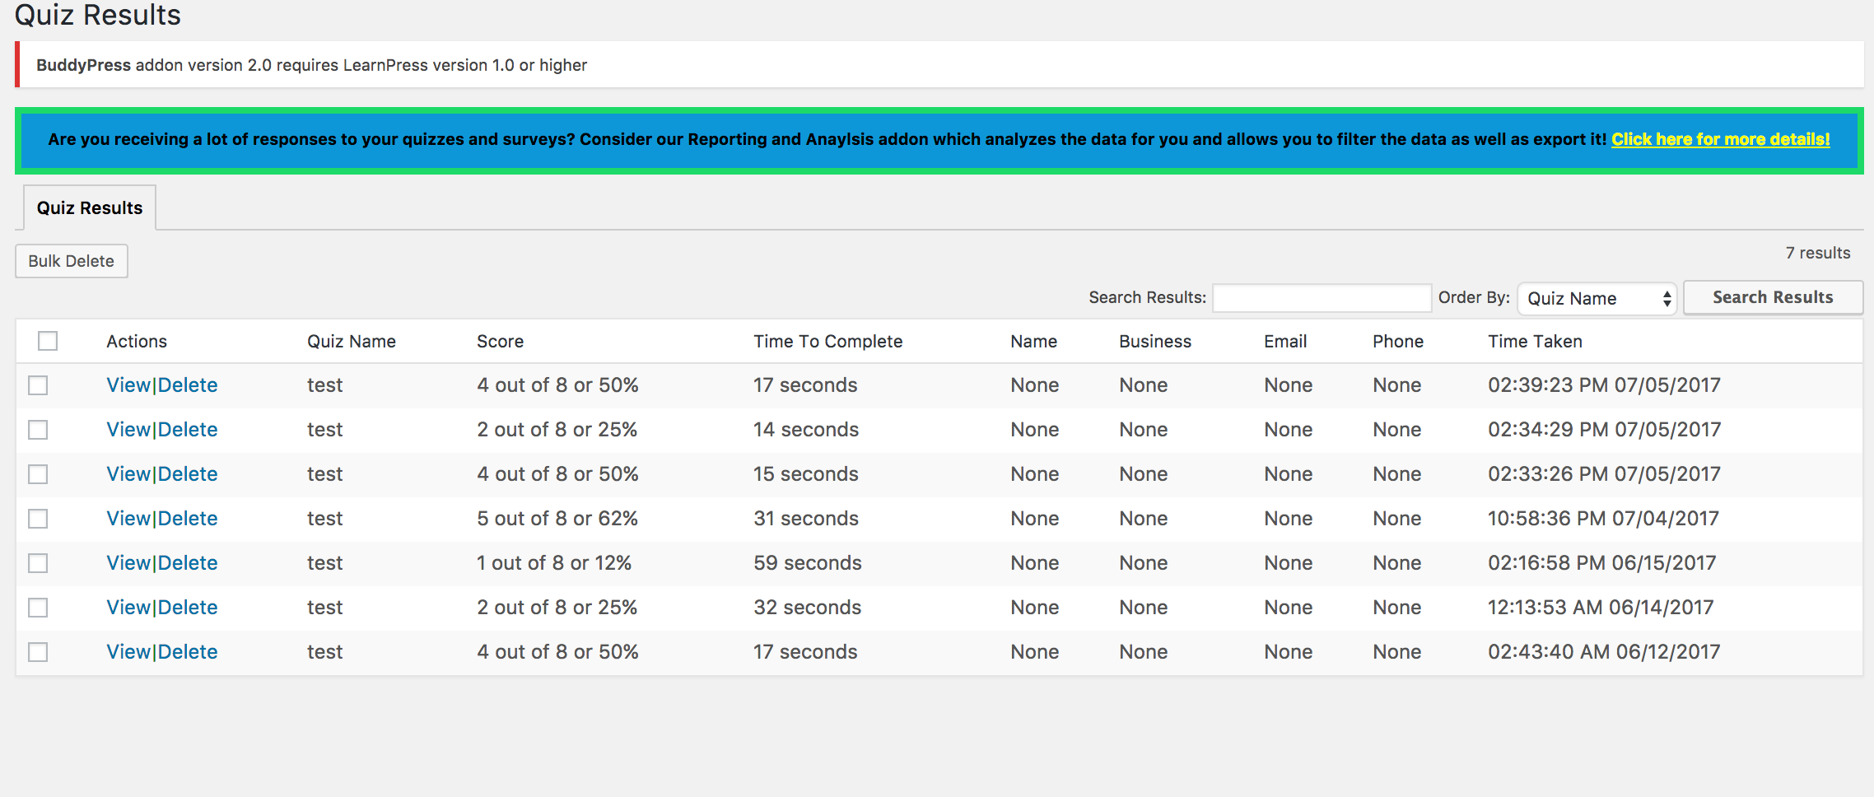

More analysis features add-ons are available but they are premium.

**Comparison table**

|  |  |  |  |  |
| --- | --- | --- | --- | --- |
| **Features\plugins** | **WP-Pro-Quiz** | **Quiz And Survey Master** | **WP Quiz** | **Watu Quizzes** |
| **Price** | **Free** | **Free and premium** | **Free** | **Free** |
| **Multiple question types with hints** | **Multiple/single choice, gap filling, drag and match, sorting choice, T/F** | **Multiple/single choice, drop down, gap filling, Accept, Number, open answer, Captcha** |  | **Multiple/single choice, open questions** |
| **HTML and multimedia allowed in questions and answers** | **HTML/picture/video** | **HTML/picture/video** |  |  |
| **Correct/incorrect response messages** | **yes** | **yes** |  |  |
| **Email notification** | **yes** | **yes** |  |  |
| **Categorization of questions** | **yes** | **yes** |  |  |
| **Custom fields** | **yes** | **no** |  |  |
| **Import and export data** | **yes** | **yes** |  |  |
| **Basic statistics and leaderboard available** | **yes** | **yes** |  |  |
| **Styling** | **Very basic default styling** | **More options** |  |  |
| **Documentation** | **Limited documentation** | **Good documentation** |  |  |
| **Start quiz button** | **yes** | **no** |  |  |
| **Data analysis** | **yes** | **yes** |  |  |
|  |  |  |  |  |
|  |  |  |  |  |